MAR ATHANASIUS COLLEGE OF ENGINEERING

KOTHAMANGALAM

(Government Aided Autonomous Institution)



Department of Computer Applications

Mini Project Report

NutriRisk - ML Based Packaged Food Nutrition Risk Analyzer
Done by
JOYAL JINS
Reg No: MAC25MCA-2034
Under the guidance of
Dr. Sonia Abraham
2025-2027

MAR ATHANASIUS COLLEGE OF ENGINEERING KOTHAMANGALAM
(Government Aided Autonomous Institution)
CERTIFICATE

NutriRisk - ML Based Packaged Food Nutrition Risk Analyzer

Certified that this is the bonafide record of project work done by
JOYAL JINS
Reg No: MAC25MCA-2034
during the third semester, in partial fulfilment of requirements for
award of the degree,
Master of Computer Applications
of

APJ Abdul Kalam Technological University, Thiruvananthapuram

Dr. Sonia Abraham Dr. Sonia Abraham
Faculty Guide Head of the Department

Dr. Manu John
Prof. Minu Maria Joseph
Project Coordinator Internal Examiner

Acknowledgement

I would like to express my sincere gratitude to everyone who supported and guided me throughout the development of my mini project, “ML-Based Packaged Food Nutrition Risk Analyzer.”
I express my heartfelt thanks to my Head of the Department and faculty members for providing me with the opportunity to undertake this project and for their valuable guidance, encouragement, and support throughout its completion.
I am especially grateful to my project guide for providing valuable suggestions, technical guidance, and constructive feedback during the various stages of development. Their support helped me improve my understanding of machine learning and web application development.
I also extend my gratitude to my institution for providing the necessary facilities and learning environment to complete this project successfully.
Finally, I thank my friends and family for their continuous encouragement and support throughout the project.

Joyal Jins

Abstract

The Machine Learning-Based Packaged Food Nutrition Risk Analyzer is a web-based application designed to evaluate the nutritional quality of packaged food products using classical machine learning techniques. The system analyzes nutritional attributes such as energy, fat, saturated fat, carbohydrates, sugars, sodium, protein, fibre, and additive count to assess the nutritional risk of food products. A Random Forest classification model is used to predict nutrition grades, which are subsequently mapped to Low, Moderate, or High Nutrition Risk categories. SHAP (SHapley Additive Explanations) is incorporated to explain the contribution of individual nutritional features to the model’s predictions, improving the interpretability of the results.

The application also provides a child-focused nutritional assessment feature that checks whether specific nutrient quantities exceed the applicable recommended limits for children. Based on the selected food category and predefined nutrient thresholds, the system identifies nutrients that exceed the specified limits and those that remain within them. Users can enter nutritional information from packaged food labels through the web interface and view the predicted nutrition grade, risk category, and relevant nutritional warnings. By presenting complex nutritional information in a simple and understandable format, the system aims to improve consumer awareness and support informed food choices. The project demonstrates the practical application of machine learning for nutrition analysis, complemented by explainable predictions and a rule-based assessment of nutrient limits for children.

The system is developed to address the difficulty consumers face in interpreting nutritional labels and comparing packaged food products. It uses 13 nutritional attributes from the Open Food Facts dataset to support nutrition-grade prediction and integrates the WHO South-East Asia Region Nutrient Profile Model for child-focused nutrient threshold assessment. By combining machine learning predictions with category-specific nutritional checks, the application provides a practical approach to understanding nutritional quality, identifying potential nutrient-limit concerns for children, and supporting informed food choices.

List of Tables
Table 2.1: Overall Summary of Selected Research Papers ...................................................... 6
Table 3.2: Nutrition Grade Categories Used as the Target Variable ...................................... 24
Table 3.3: Software / Technology Requirements ................................................................... 38
Table 3.4: Hardware Requirements ........................................................................................ 39
Table 4.1: Distribution of Training and Testing Dataset ........................................................ 41
Table 4.2: Performance Comparison of Machine Learning Models ...................................... 43
Table 4.3: Age-Based Nutrient Thresholds by Food Category .............................................. 44
Table 5.1: Classification Metrics by Nutrition Grade ............................................................ 46
Table 5.2: Evaluation Statistics .............................................................................................. 47
Table 5.3: Actual vs. Predicted Distribution .......................................................................... 47
Table 10.1: Minimum Software Requirements ...................................................................... 55
Table 10.2: Minimum Hardware Requirements ..................................................................... 55

List of Figures

Figure 3.1: Result of Shape and Datatype of Dataset ......................................................... 12

Figure 3.2: First Five Records of the Open Food Facts Dataset ......................................... 12

Figure 3.3: Statistical Summary of the Open Food Facts Dataset ...................................... 13

Figure 3.4: Distribution of the Nutrition Grade (nutrition_grade_fr) ................................. 14

Figure 3.5: Distribution of Energy and Sugar Content ....................................................... 14

Figure 3.6: Distribution of Saturated Fat and Additives Count .......................................... 15

Figure 3.7: Top 10 Product Categories ............................................................................... 15

Figure 3.8: Most Frequent Additives .................................................................................. 16

Figure 3.9: Average Sugar Content by Product Category .................................................. 16

Figure 3.10: Correlation Heatmap of the Selected Nutritional Features ............................ 17

Figure 3.11: Outlier Analysis of Saturated Fat and Sugar Content .................................... 18

Figure 3.12: Outlier Analysis of Sodium and Fibre ............................................................ 18

Figure 3.13: Missing Values in the Selected Nutritional Features ..................................... 20

Figure 3.14: Dataset Shape Before and After Handling Missing Values ........................... 20

Figure 3.15: Duplicate Record Analysis ............................................................................. 21

Figure 3.16: Label Encoding of the Nutrition Grade .......................................................... 21

Figure 3.17: Training and Testing Dataset Preparation ...................................................... 22

Figure 3.18: Flowchart of Decision Tree Algorithm .......................................................... 26

Figure 3.19: Flowchart of Random Forest Algorithm ........................................................ 28

Figure 3.20: Flowchart of Logistic Regression Algorithm ................................................. 31

Figure 3.21: Activity Diagram of the Proposed Nutrition Risk Analyzer .......................... 33

Figure 3.22: Project Pipeline of the Proposed Nutrition Risk Analyzer ............................. 35

Figure 5.1: Confusion Matrix of Random Forest ................................................................ 46

Figure 6.1: Home Page ....................................................................................................... 49

Figure 6.2: Nutritional Input Form ..................................................................................... 50

Figure 6.3: Nutrition Analysis Result Interface .................................................................. 50
Figure 6.4: Child-Focused Nutrition Check Interface …………………………………….51
Figure 6.5: Prediction Explanation Interface……………………………………………....51
Figure 7..1: Overall Project Repository on GitHub………………………………………..52
Figure 7.2: Directory Structure of the Project on GitHub ...................................................53
Figure 7.3: Source Code of the Application on GitHub ..................................................... 53

Contents
Acknowledgement i
Abstract ii
List of Tables iii
List of Figures iv
1. INTRODUCTION ………………………………………………………………………1
2. SUPPORTING LITERATURE ………………………………………………………..2
2.1 Literature Review ...……………………………………………………………..2
2.2 Findings and Proposals ………………………………………………………….6
2.3 Problem Statement ………………………………………………………………6
2.4 Research Gap ……………………………………………………………………7
2.5 Motivation ………………………………………………………………………7
3. SYSTEM ANALYSIS …………………………………………………………………..8
3.1 Analysis of Dataset ……………………………………………………………...8
3.1.1 About the Dataset ……………………………………………………...8
3.1.2 Exploratory Data Analysis …………………………………………...13
3.2 Data Preprocessing …………………………………………………………….19
3.2.1 Data Cleaning ………………………………………………………..19
3.2.2 Analysis of Feature Variables ………………………………………..22
3.2.3 Analysis of Class Variables ………………………………………….23
3.3 Analysis of Architecture and Algorithms ………………………………………24
3.3.1 Detailed Study of the Proposed Algorithms …………………………25
3.3.2 Activity Diagram …………………….………………………………32
3.3.3 Working of the Proposed System ……………………………………34
3.4 Project Pipeline ………………………………………………………………...34
3.6 Feasibility Analysis …………………………………………………………….37
3.7 System Environment …………………………………………………………...38
4. SYSTEM DESIGN ……………………………………………………………………..39
4.1 Models Building ……………………………………………………………….39
4.2 Age-Based Nutritional Analysis ……………………………………………….43
5. RESULTS AND DISCUSSION ……………………………………………………….45
5.1 Comparison of Models …………………………………………………………45
5.2 Evaluation Metrics ……………………………………………………………..45
5.3 Confusion Matrix ………………………………………………………………45
5.4 Relevant Metrics from the Confusion Matrix ………………………………….46
5.5 Prediction Statistics of Unseen Data …………………………………………...47
5.6 Discussion of Findings …………………………………………………………47
5.7 Conclusion ……………………………………………………………………..48
6. MODEL DEPLOYMENT ……………………………………………………………..48
6.1 Model Implementation …………………………………………………………48
6.2 UI Design ………………………………………………………………………48
7. GIT HISTORY …………………………………………………………………………52
8. CONCLUSIONS ……………………………………………………………………….54
9. FUTURE SCOPE ………………………………………………………………………54
10. APPENDIX ……………………………………………………………………………55
11. REFERENCES ……………………………………………………………………….56

1. Introduction
The increasing consumption of packaged food products has made nutritional awareness an important aspect of maintaining a healthy lifestyle. Consumers rely on nutrition labels to understand the nutritional composition of food products; however, interpreting values such as energy, carbohydrates, sugars, fat, saturated fat, sodium, protein, and fibre can be difficult for the general public. Although nutrition labels provide detailed information, they do not always offer a simple overall assessment of a product's nutritional quality. As a result, consumers may find it challenging to compare products and make informed dietary decisions.
Unhealthy dietary habits and excessive intake of nutrients such as sugars, saturated fat, sodium, and energy may contribute to various diet-related health conditions. Existing approaches often require consumers to examine multiple nutritional values manually or interpret nutrition grading information, which may not always be straightforward. Therefore, a system that simplifies nutritional information and presents the results in an understandable format can help consumers evaluate packaged food products more conveniently.
Machine Learning (ML) provides an effective approach for analysing nutritional data and identifying patterns among multiple nutritional attributes. By learning from food products with known nutrition grades, machine learning models can predict the nutrition grade of new products based on their nutrient composition. Classical machine learning algorithms, such as Random Forest, Decision Tree, and Logistic Regression, can process multiple nutritional attributes simultaneously and support multiclass nutrition-grade prediction without requiring deep learning techniques.
This project, “ML-Based Packaged Food Nutrition Risk Analyzer,” proposes a web-based application that predicts the nutrition grade of packaged food products using 13 nutritional attributes: energy, fat, saturated fat, carbohydrates, sugars, sodium, protein, fibre, cholesterol, trans fat, calcium, iron, and additives count. The prediction model is trained using data from the Open Food Facts dataset. In addition to the machine learning prediction, the application includes a separate Child-Focused Nutrition Check based on the World Health Organization (WHO) South-East Asia Region Nutrient Profile Model. This rule-based component compares available nutrient values against applicable thresholds for the selected food category and identifies nutrients that exceed those thresholds.
The proposed system aims to simplify nutritional information by combining machine learning-based nutrition-grade prediction with a separate rule-based nutrient threshold assessment. Through a user-friendly web application, the system presents nutritional results in an understandable format, helping consumers evaluate packaged food products and make more informed dietary choices.

2. Supporting Literature
2.1 Literature Review
Paper 1 – Menichetti, G., Ravandi, B., Mozaffarian, D., & Barabási, A.-L. (2023). Machine Learning Prediction of the Degree of Food Processing. Nature Communications, 14, 2312.
This research paper presents a Machine Learning framework named FoodProX for automatically predicting the degree of food processing using nutritional information. The study was developed to overcome the limitations of the traditional NOVA food classification system, which categorizes foods into four processing levels but relies heavily on manual classification. The authors explain that existing food processing classification methods are incomplete, subjective, and unable to classify many packaged food products consistently. To address this problem, they proposed a machine learning-based system capable of predicting the processing level of any food directly from its nutritional composition.
The proposed FoodProX model uses nutritional values such as proteins, carbohydrates, fats, vitamins, minerals, fibre, sodium, sugars, and other nutrients to determine whether a food belongs to one of the four NOVA processing categories. The study utilised food composition datasets obtained from the USDA Food and Nutrient Database for Dietary Studies (FNDDS) together with manually labelled NOVA classifications for model training. Additional validation was performed using NHANES (National Health and Nutrition Examination Survey) data and Open Food Facts, allowing the researchers to evaluate the model on a large number of packaged food products.
The authors developed FoodProX using a Random Forest classifier trained on nutrient information from food products. The model predicts the probability that a food belongs to each NOVA category and further computes a continuous Food Processing Score (FPro), which measures the degree of processing instead of assigning only a fixed class label. The study employed preprocessing techniques such as logarithmic transformation of nutrient values, feature engineering, five-fold cross-validation, ensemble learning, and Synthetic Minority Over-sampling Technique (SMOTE) to improve model performance and reduce class imbalance. Performance was evaluated using Area Under the ROC Curve (AUC), precision, recall, and cross-validation analysis.
The experimental results demonstrated that FoodProX achieved excellent classification performance, with AUC values close to 0.98 across all NOVA categories, indicating that nutrient composition alone can accurately predict the processing level of food products. The study further revealed that approximately 73% of the US food supply is classified as ultra-processed. Using NHANES dietary records, the researchers also found strong associations between higher consumption of ultra-processed foods and increased risks of metabolic syndrome, diabetes, cardiovascular diseases, elevated blood pressure, reduced vitamin availability, and accelerated biological ageing. The authors additionally showed that replacing highly processed foods with less processed alternatives can significantly reduce these health risks.
This paper is highly relevant to the proposed project because it demonstrates how Machine Learning can analyse nutritional information to classify food products automatically. While the proposed project predicts the nutritional risk level of packaged canned foods using machine learning algorithms such as Random Forest, Decision Tree, and Logistic Regression, this research validates that nutritional attributes provide sufficient information for accurate food quality assessment. The study therefore provides strong technical support for developing an intelligent packaged food safety and nutrition evaluation system.

Paper 2 – Razavi, R., & Xue, G. (2023). Predicting Unreported Micronutrients From Food Labels: Machine Learning Approach. Journal of Medical Internet Research, 25, e45332.
This research paper investigates the use of Machine Learning to predict micronutrients that are not listed on standard food labels, helping consumers obtain more comprehensive nutritional information without laboratory analysis. The authors explain that although nutrition labels provide details such as calories, fat, carbohydrates, protein, sodium, and sugars, important vitamins and minerals are often omitted because of regulatory limitations and limited label space. Since deficiencies in essential micronutrients affect billions of people worldwide, the study proposes an intelligent machine learning approach to estimate these missing nutritional values from the information already available on food labels.
The study utilized the USDA Food and Nutrient Database for Dietary Studies (FNDDS) 2019–2020, containing 5,624 food products with complete nutritional information. The dataset includes both commonly reported nutrients and micronutrients such as vitamins A, C, B-complex, E, K, magnesium, zinc, phosphorus, selenium, manganese, and copper. The reported nutrition label attributes were used as input features, while the unreported micronutrients served as prediction targets. The researchers performed extensive preprocessing, feature selection, hyperparameter tuning, and repeated cross-validation to ensure reliable model performance and minimize overfitting.
The authors evaluated a wide range of Machine Learning algorithms for both regression and classification tasks, including Random Forest, Gradient Boosting Machine, Support Vector Machine, Decision Tree, Linear Regression, Ridge Regression, LASSO, Elastic Net, k-Nearest Neighbors, and Neural Networks. The study found that while predicting the exact quantity of micronutrients was difficult, classification models were highly effective in categorizing micronutrient levels as Low, Medium, or High. Non-linear models, particularly ensemble-based approaches such as Random Forest and Gradient Boosting, consistently outperformed linear models. The research also performed variable importance analysis to identify which nutrition label attributes contributed most significantly to prediction performance.
The experimental results demonstrated that the classification models achieved prediction accuracies exceeding 80% for all vitamins and minerals. The highest classification accuracy was obtained for Vitamin B12 (94%) and Phosphorus (94%), while Vitamin E (81%) and Selenium (83%) showed comparatively lower prediction accuracy. The study concluded that machine learning can successfully estimate missing micronutrients using existing nutrition label information and recommended integrating these predictive models into mobile applications to provide consumers with personalized nutritional guidance and improve public health awareness.
This paper is highly relevant to the proposed project because it demonstrates that nutritional values available on food labels are sufficient for building accurate machine learning prediction models. Similar to the proposed Machine Learning-Based Packaged Food Nutrition Risk Analyzer, the study relies entirely on nutritional attributes rather than image analysis or laboratory testing. The successful application of Random Forest and other classical machine learning algorithms provides strong support for using structured nutritional information to predict food-related health indicators and deliver meaningful nutritional recommendations to consumers.

Paper 3 – Muthukumar, K. A., Gupta, S., & Saikia, D. (2024). Leveraging Machine Learning Techniques to Analyse Nutritional Content in Processed Foods. Discover Food, 4, 182.
This research paper presents a Machine Learning framework for predicting protein retention in processed plant-based foods. The authors explain that food processing methods such as boiling, steaming, roasting, grilling, and other thermal treatments can significantly affect the nutritional quality of food, particularly protein content. Since laboratory analysis of nutrient retention is expensive and time-consuming, the study proposes using machine learning techniques to accurately estimate protein retention after food processing. The objective is to assist the food industry in developing healthier processing techniques while reducing the dependence on laboratory testing.
The researchers constructed a comprehensive dataset by collecting nutritional information from published scientific literature available in Web of Science, Scopus, PubMed, and Google Scholar. Following the PRISMA methodology, the collected data were organized into a structured dataset containing information such as food type, processing method, temperature, moisture, processing time, pH, and protein content before and after processing. Data preprocessing included cleaning, normalization, feature selection, and hyperparameter tuning to improve prediction accuracy and model reliability.
The study implemented two primary Machine Learning algorithms: Support Vector Regression (SVR) and Random Forest (RF) using the Scikit-learn library. To further improve model performance, the authors applied GridSearchCV for hyperparameter optimization and performed Feature Importance Analysis to determine the processing variables that most strongly influence nutrient retention. Model performance was evaluated using Normalized Mean Squared Error (NMSE), R² score, computational time, and residual analysis. The study also compared the performance of Gradient Boosting Machine (GBM), Ridge Regression, and Linear Regression to provide a comprehensive evaluation of different regression techniques.
The experimental results showed that Support Vector Regression outperformed Random Forest in predicting protein retention. The SVR model achieved an NMSE of approximately 0.13 and an R² value of 0.89, while the Random Forest model achieved an NMSE of approximately 0.35 and an R² value of 0.76. The study also identified temperature, processing duration, and moisture as the most influential factors affecting nutrient retention. The authors concluded that Machine Learning provides an efficient and reliable approach for predicting nutritional changes in processed foods and can significantly reduce the need for extensive laboratory analysis.
This paper is relevant to the proposed project because it demonstrates that Machine Learning can successfully analyse nutritional characteristics of processed foods using structured data. Although the study focuses on predicting protein retention, while the proposed project predicts nutrition grade and nutrition risk, both systems utilize nutritional information and machine learning models to evaluate food quality. The paper also highlights the importance of feature selection, preprocessing, and model comparison, which are incorporated into the proposed Machine Learning-Based Packaged Food Nutrition Risk Analyzer.
TITLE | SUMMARY | Explicit Results/Metrics
Menichetti, G., Ravandi, B., Mozaffarian, D., & Barabási, A.-L. (2023). Machine Learning Prediction of the Degree of Food Processing. Nature Communications, 14, 2312. | This study proposes FoodProX, a Random Forest-based framework for predicting food processing levels from nutritional composition. The model was trained using USDA FNDDS data and validated using NHANES and Open Food Facts. The study demonstrates that nutritional information can effectively predict food processing levels. | AUC ≈ 0.98 across NOVA categories; approximately 73% of the US food supply classified as ultra-processed
Razavi, R., & Xue, G. (2023). Predicting Unreported Micronutrients From Food Labels: Machine Learning Approach. Journal of Medical Internet Research, 25, e45332. | This research uses Machine Learning to predict unreported vitamins and minerals from existing food-label information. The study evaluated several models, including Random Forest, Gradient Boosting, Decision Tree, and Support Vector Machine, using USDA FNDDS data. It demonstrates that nutritional label information can be used to estimate missing micronutrients. | Classification accuracy >80% for all vitamins/minerals; highest 94% for Vitamin B12 and Phosphorus; lowest reported examples 81% Vitamin E and 83% Selenium
Muthukumar, K. A., Gupta, S., & Saikia, D. (2024). Leveraging Machine Learning Techniques to Analyze Nutritional Content in Processed Foods. Discover Food, 4, 182. | This study uses Machine Learning to predict protein retention in processed plant-based foods based on processing conditions and nutritional characteristics. It compares Support Vector Regression (SVR) and Random Forest models and identifies important factors affecting protein retention. | SVR: NMSE ≈ 0.13, R² ≈ 0.89; RF: NMSE ≈ 0.35, R² ≈ 0.76
Table 2.1 Overall Summary of Selected Research Papers

2.2 Findings and Proposals
The reviewed studies demonstrate that Machine Learning can effectively analyse structured nutritional information for food-related prediction and classification tasks. The studies show that nutritional attributes such as energy, fats, carbohydrates, sugars, protein, fibre, sodium, vitamins, and minerals can provide useful predictive information. The reviewed research also highlights the importance of preprocessing, feature selection, and model comparison when developing reliable Machine Learning models.
However, the reviewed studies primarily address food-processing classification, micronutrient prediction, and nutrient retention, rather than providing a consumer-oriented system for assessing the overall nutritional quality of packaged food products. Based on these findings, the proposed project focuses on predicting nutrition grades (A–E) from nutritional composition using the Open Food Facts dataset and comparing Decision Tree, Random Forest, and Logistic Regression models. The predicted grade is further combined with the user's age group to provide a simplified nutrition-risk classification.
2.3 Problem Statement
Consumers often find it difficult to interpret the multiple nutritional values provided on packaged food labels. Although labels contain information such as energy, fat, saturated fat, sugars, sodium, protein, and fibre, manually comparing these attributes to determine the overall nutritional quality of a product can be complex and time-consuming.
Existing approaches may require manual interpretation of nutritional information or expert knowledge and may not provide a simple, personalized assessment for consumers. Therefore, there is a need for a system that can automatically analyse nutritional information, predict the nutrition grade of packaged food products, and present the result in an easy-to-understand form.
The proposed Packaged Food Nutrition Risk Analyzer addresses this problem by applying Machine Learning to predict the nutrition grade (A–E) from nutritional attributes and combining the prediction with the user's age group to provide a Low, Moderate, or High Nutrition Risk classification.
2.4 Research Gap
The reviewed literature demonstrates successful applications of Machine Learning in food and nutrition, including food-processing classification, prediction of unreported micronutrients, and analysis of nutritional changes in processed foods. However, these studies do not directly focus on predicting an overall nutrition grade for packaged food products and presenting the result through a consumer-oriented application.
Furthermore, the reviewed studies primarily provide predictions related to nutritional or food-processing characteristics rather than converting these results into a simple nutrition-risk interpretation for individual users. The proposed project addresses this gap by developing a web-based system that predicts nutrition grades from nutritional composition and combines the predicted grade with the user's age group to provide an understandable nutrition-risk category.

2.5 Motivation
The increasing consumption of packaged food products makes it important for consumers to understand the nutritional quality of the foods they purchase. However, interpreting several nutritional values simultaneously can be difficult, particularly when comparing multiple products.
The motivation for this project is therefore to develop a simple and accessible system that transforms nutritional information into an understandable assessment. By applying classical Machine Learning algorithms to structured nutritional data and presenting the result through a web-based application, the proposed system aims to assist consumers in interpreting nutrition grades and making more informed food choices.

3. System Analysis
The Open Food Facts dataset, sourced from Kaggle, provides a comprehensive collection of packaged food products containing detailed nutritional information suitable for Machine Learning applications in food quality assessment. The dataset consists of nutritional values, food categories, ingredient information, and nutrition grades, making it appropriate for developing intelligent nutrition analysis systems. It enables the analysis of nutritional composition and supports the development of an automated nutrition grade prediction system that assists consumers in making healthier food choices.
Dataset Link:https://www.kaggle.com/datasets/openfoodfacts/world-food-facts
Size: The dataset initially contains approximately 190,000 packaged food products with 163 attributes describing various nutritional and product-related characteristics. After preprocessing, 123,938 records were retained for Machine Learning model development and evaluation. This provides a substantial number of labelled food products for training and testing the nutrition-grade classification models.

Data Structure: The dataset consists of numerical, categorical, and text attributes. The selected input features include nutritional values such as energy, fat, saturated fat, carbohydrates, sugars, sodium, protein, fibre, cholesterol, trans fat, calcium, iron, and additives count, while the target variable is nutrition_grade_fr, which represents the nutrition grade of each food product (A–E). These labelled nutrition grades enable supervised Machine Learning algorithms to learn the relationship between nutritional composition and nutrition grade.

Preprocessing Considerations: The dataset contains nutritional information collected from packaged food products, but several attributes contain missing or invalid values. Therefore, preprocessing is performed before model training, including handling missing values, removing invalid and nutritionally inconsistent records, selecting relevant features, encoding the target variable, and performing an 80/20 stratified train-test split. These steps prepare the dataset for training and evaluating the Decision Tree, Random Forest, and Logistic Regression models.
3.1 Analysis of Dataset
3.1.1 About the Dataset
a) Dataset Overview
The Open Food Facts dataset, sourced from Kaggle, contains a large collection of packaged food products with detailed nutritional and product-related information. The dataset is designed for food analysis and Machine Learning applications, enabling the prediction of nutritional quality based on the nutrient composition of food products. Each record represents a packaged food item and includes nutritional values, product information, and a corresponding nutrition grade (A–E), making it suitable for supervised Machine Learning.
The dataset is used to train the Machine Learning models employed in the proposed Machine Learning-Based Packaged Food Nutrition Risk Analyzer. The nutritional information available in the dataset enables the system to learn the relationship between nutrient composition and nutrition grade, which is later used to classify food products and provide an age-based nutrition risk assessment.
- Total Records: Approximately 190,000 packaged food products in the original dataset. After preprocessing, including handling missing values, removing invalid and inconsistent records, the final dataset contains 123,938 records.
- Total Features: 163 attributes, from which 13 input features and 1 target variable were selected for the project.
- Data Types: Numerical, Categorical, and Text.
- Missing Values: Several attributes contain missing values. Missing and incomplete records relevant to the selected features were handled during preprocessing before training the Machine Learning models.
- Target Variable: nutrition_grade_fr, representing the nutrition grade of each food product from A to E.
Feature Categories
1. Input Features and Feature Selection
The original dataset retrieved from Open Food Facts contained 163 raw attributes per food product. However, utilising the full feature space directly for machine learning poses significant operational challenges, including severe data sparsity (missingness), high dimensionality leading to the curse of dimensionality, and the inclusion of non-predictive metadata (e.g., barcode numbers, packaging labels, URLs). To construct a robust, high-performing, and academically defensible input feature vector, a rigorous domain-driven feature selection process was performed to select a final set of 13 features.
Feature Selection Rationale & Academic Framework
The reduction from 163 candidate fields down to 13 core features is supported by both machine learning benchmark literature and global nutrient profiling frameworks:
- Machine Learning Precedent (FoodProX Framework): Primary methodological support is drawn from FoodProX (D. et al., Nature Communications, 2023). The authors evaluated model performance across three nutrient-panel sizes—12, 62, and 99 nutrients—using five-fold stratified cross-validation. Crucially, the authors highlighted that 90% of foods in the USDA Branded Food Products Database reported fewer than 17 nutrients, justifying the use of a compact 12-nutrient panel based on the standard FDA label. Despite the reduced feature set, this smaller panel achieved high predictive performance, yielding AUC values of approximately 0.96–0.98 across NOVA classification tiers. Furthermore, FoodProX specifically evaluated adding an additive count feature to the nutritional profile in Open Food Facts experiments, proving it provides a measurable boost in classification accuracy.
- Nutrient Profiling Rationale: Broad health-risk justification comes from global nutrient profiling models (e.g., Drewnowski et al., 2021) and systematic reviews of international nutrition policies. These frameworks establish that health-risk algorithms must balance nutrients to limit (energy, saturated fat, total sugars, sodium, trans fat) against nutrients to encourage (protein, dietary fiber, key minerals).
Final 13 Input Features
The final set of 13 features selected for model training and their specific academic justifications are listed below:
No. | Feature Name | Role / Category | Academic & Methodological Justification
1 | Energy | Caloric Density | Core metric in global nutrient profiling frameworks (Drewnowski et al., 2021).
2 | Fat | Macronutrient | Included in the FoodProX compact 12-nutrient FDA panel.
3 | Saturated Fat | Nutrient to Limit | Present in ~88% of global regulatory nutrient profiles; key marker for cardiovascular risk.
4 | Carbohydrates | Macronutrient | Standard macro-level predictor in FoodProX feature sets.
5 | Sugars | Nutrient to Limit | Appears in ~88% of policy profile models; directly linked to metabolic health risk.
6 | Sodium | Nutrient to Limit | Featured in 100% of reviewed policy nutrient models; key risk factor for hypertension.
7 | Protein | Nutrient to Encourage | Standard positive nutrient in profiling systems and included in the FoodProX panel.
8 | Fiber | Nutrient to Encourage | Present in 88% of regulatory models; strongly differentiates whole foods from ultra-processed formulations.
9 | Cholesterol | Lipid Profile | Part of the core 12-nutrient FDA panel tested in FoodProX.
10 | Trans Fat | Nutrient to Limit | Supported by FoodProX and FDA labeling standards as a marker for industrial processing.
11 | Calcium | Essential Mineral | Included in 50% of policy models as a positive nutrient and present in FoodProX panels.
12 | Iron | Essential Mineral | Included in 50% of policy models as a positive nutrient and present in FoodProX panels.
13 | Additives | Formulation Marker | Tested explicitly in FoodProX on Open Food Facts data, demonstrating performance gains when combined with nutritional features.

2. Target Variable
- nutrition_grade_fr – Represents the nutrition grade assigned to each packaged food product.
The dataset contains five nutrition grade categories:
- A
- B
- C
- D
- E
These labelled grades enable supervised Machine Learning algorithms to learn the relationship between nutritional composition and overall nutritional quality. After predicting the nutrition grade, the proposed system further considers the user's age group to classify the product into Low, Moderate, or High Nutrition Risk, providing users with a simple and personalized nutritional assessment.
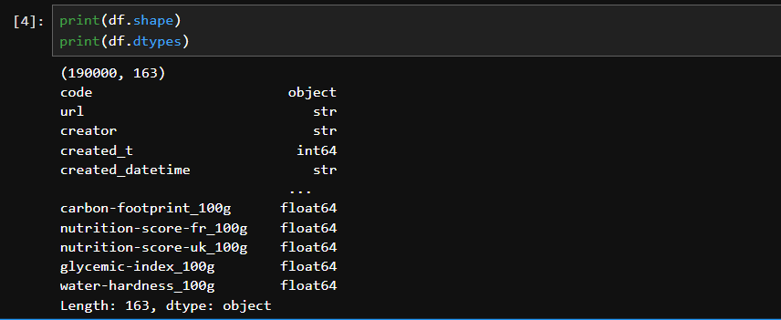
Figure 3.1 Result of shape and datatype of dataset

b) Dataset Sample Records
This section displays the first five records of the Open Food Facts dataset to provide an initial understanding of the dataset structure, nutritional attributes, and product information. It helps verify that the dataset has been loaded correctly and provides an overview of the nutritional values and the corresponding nutrition grades (A–E) assigned to each packaged food product before data preprocessing.
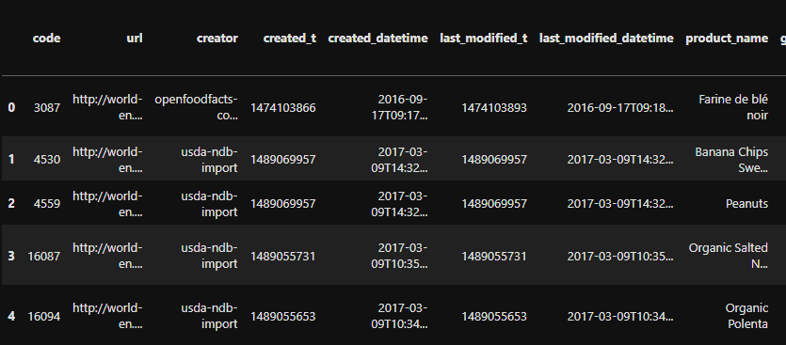
Figure 3.2: First five records of the Open Food Facts dataset

c) Summary Statistics
The describe() function is used to generate summary statistics for the numerical attributes in the dataset. It provides statistical measures such as the count, mean, standard deviation, minimum value, maximum value, and quartile values (25%, 50%, and 75%) for each nutritional feature. These statistics help in understanding the distribution and characteristics of the nutritional attributes before data preprocessing and Machine Learning model development.
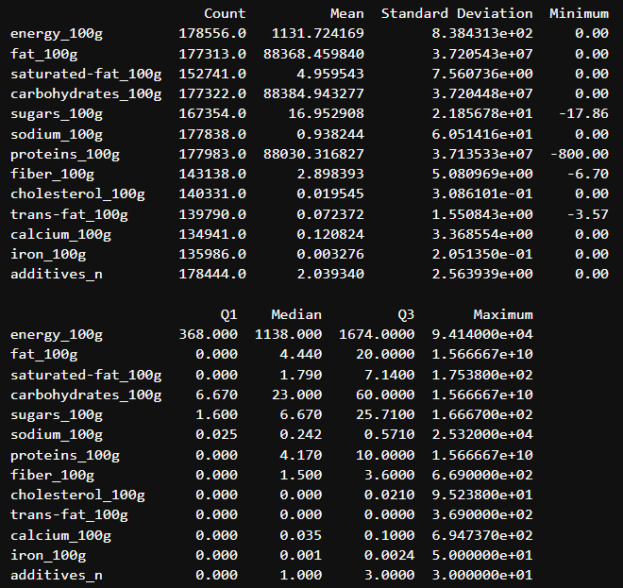
Figure 3.3: Statistical summary of the Open Food Facts dataset.

3.1.2 Exploratory Data Analysis
a) Distribution of the Target Variable
Purpose: The distribution of the target variable (nutrition_grade_fr) is visualized using a bar chart to understand the frequency of each nutrition grade in the dataset. This analysis helps determine whether the dataset is balanced across the five nutrition grade categories (A, B, C, D, and E) before training the Machine Learning models. Understanding the class distribution is important because highly imbalanced classes may affect the prediction performance and reliability of the trained models.

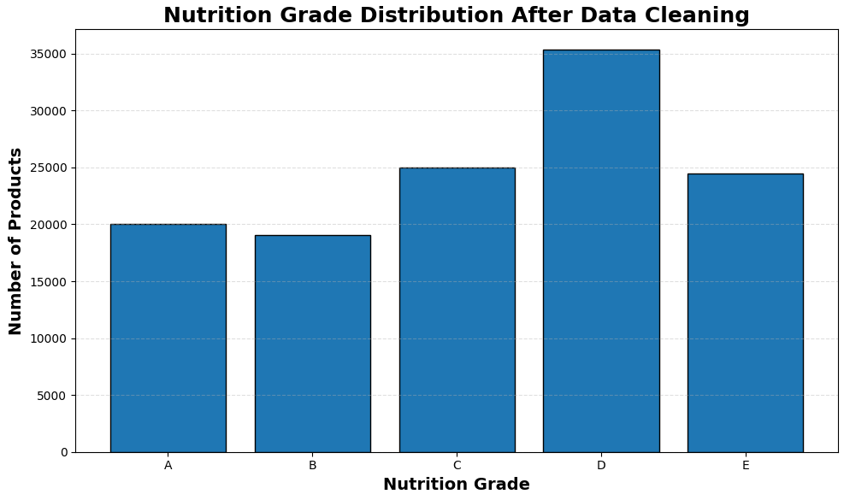
Figure 3.4: Distribution of the Nutrition Grade (nutrition_grade_fr)

b) Distribution of Numerical Features
Purpose: The distribution of important numerical nutritional features is visualized using histograms to understand the spread and frequency of values within the dataset. These visualizations help identify the distribution pattern, skewness, and variability of nutritional attributes before data preprocessing and Machine Learning model development. Understanding the distribution of the input features also assists in detecting potential outliers and determining whether additional preprocessing is required.
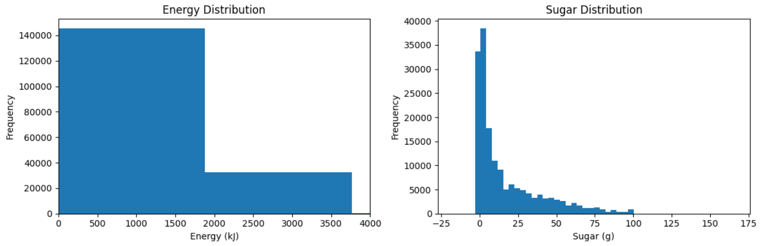
Figure 3.5: Distribution of Energy and Sugar Content.

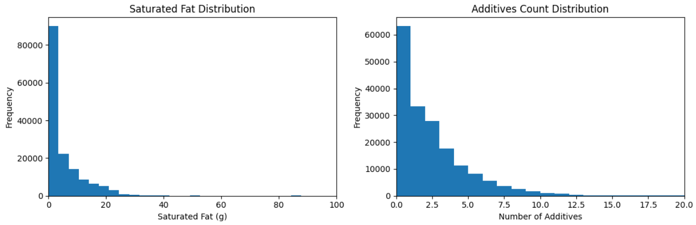
Figure 3.6: Distribution of Saturated Fat and Additives Count.
c) Product and Food Characteristics
In addition to nutritional attributes, the dataset contains product-related characteristics that provide information about the composition and nature of packaged food products. Two important characteristics examined in this analysis are the number of additives and sugar content across different product categories. Additives provide an indication of the extent to which different products contain added substances, while sugar content helps compare the nutritional composition of different food categories.
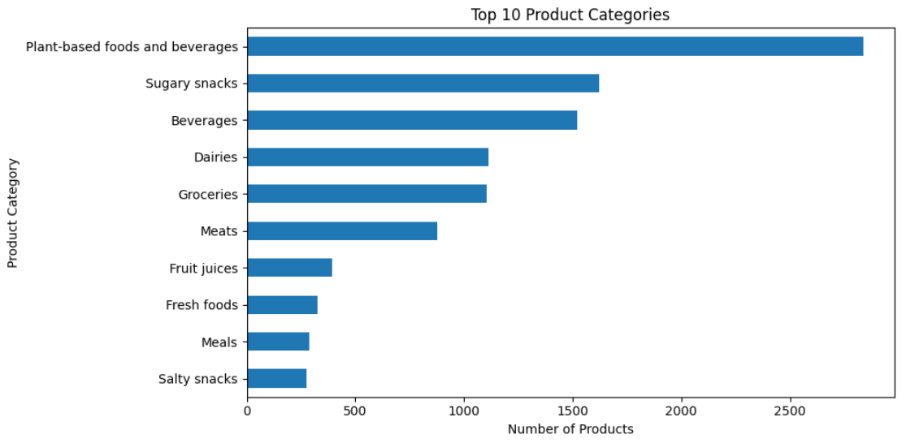
Figure 3.7: Top 10 Product Categories
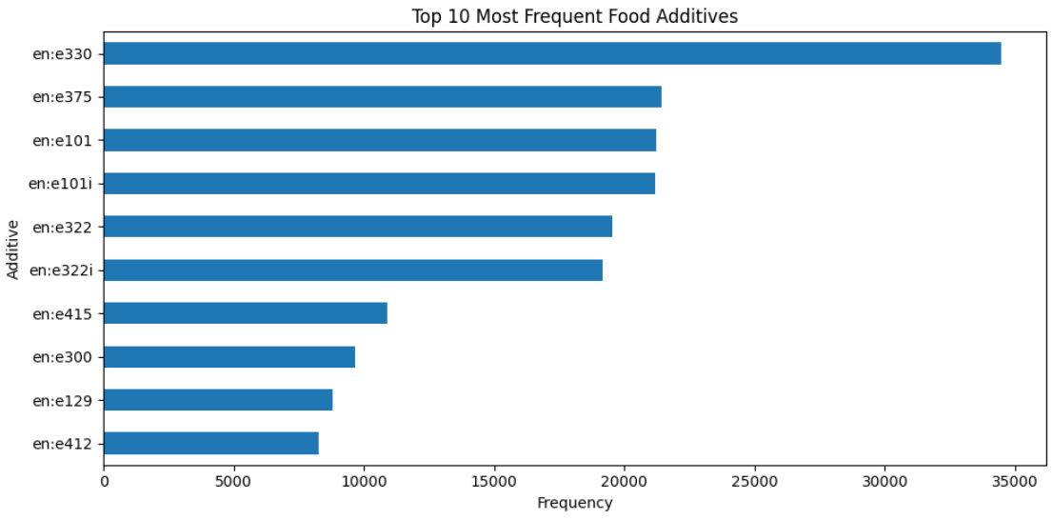
Figure 3.8: Most Frequent Additives

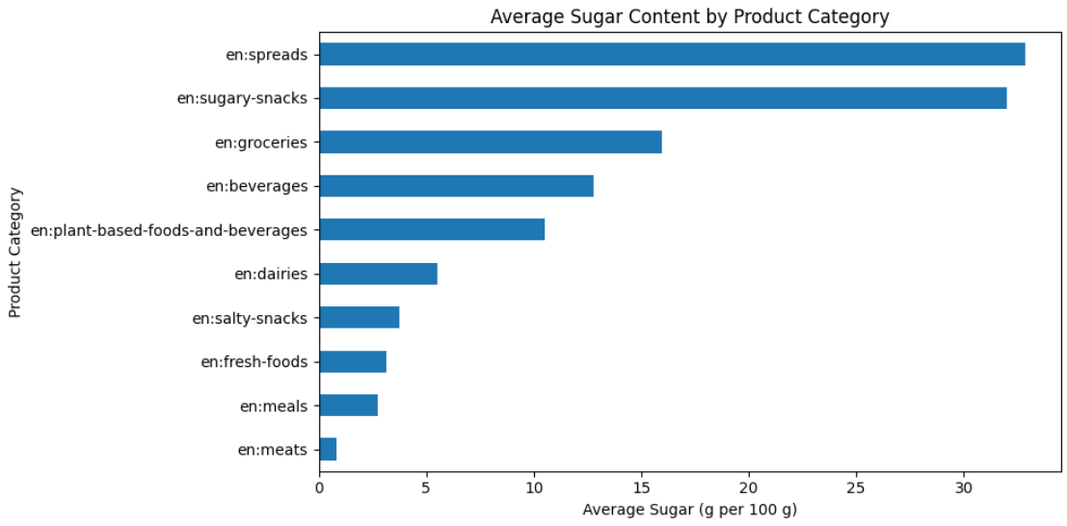
Figure 3.9: Average Sugar Content by Product Category

d) Correlation Analysis
Purpose: A correlation heatmap is generated to analyse the relationship between the selected numerical nutritional features. It helps identify positive and negative correlations among the variables and provides insights into how different nutritional attributes influence one another. This analysis is useful for understanding feature relationships and identifying potential multicollinearity before training the Machine Learning models.

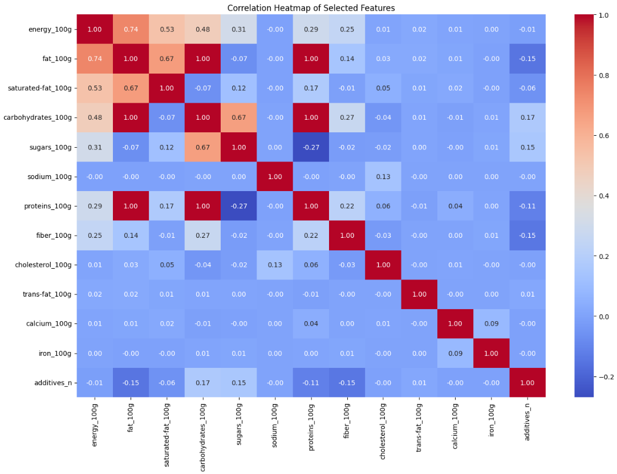
Figure 3.10: Correlation heatmap of the selected nutritional features.
Correlation Heatmap
Energy and Fat: r = 0.77 → strong positive correlation.
Fat and Saturated Fat: r = 0.69 → moderately strong positive correlation.
Carbohydrates and Sugars: r = 0.63 → moderately strong positive correlation.
Protein and Sugars: r = −0.28 → weak-to-moderate negative relationship.
Carbohydrates and Protein: r = −0.14 → weak negative relationship.
Fat and Additives: r = −0.12 → weak negative relationship.
Protein and Additives: r = −0.12 → weak negative relationship.
Most other feature pairs have correlations close to 0, indicating weak linear relationships.

e) Box Plot of Numerical Features
Purpose: Box plots are generated to visualize the distribution, median, spread, and potential outliers of the selected numerical nutritional features. This analysis helps identify extreme values and understand the variability of the nutritional attributes before data preprocessing and Machine Learning model training.

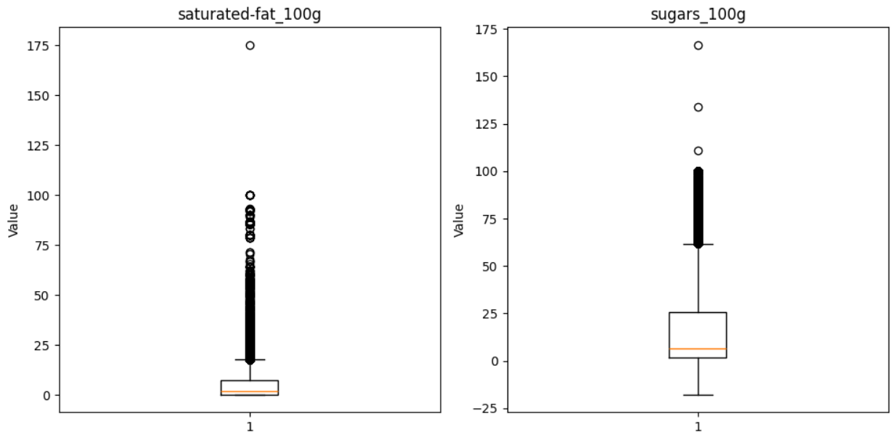
Figure 3.11: Saturated Fat & Sugar

Analysis: The box plots reveal substantial variability and several potential outliers in the nutritional attributes. These observations were further examined using domain-based validation checks to distinguish legitimate extreme food values from invalid or unrealistic records

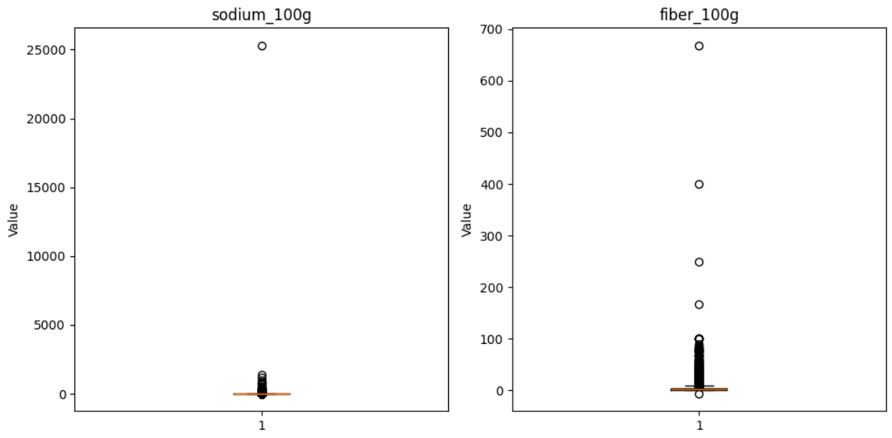
Figure 3.12: Sodium & Fiber

Outlier and Validity Checks
The selected numerical attributes were examined for invalid, inconsistent, and extreme values before model training. Negative values in the selected nutritional attributes were identified and treated as invalid. Domain-based consistency checks were also performed to identify nutritionally impossible relationships, including saturated fat exceeding total fat, sugars exceeding total carbohydrates, and trans fat exceeding total fat. Values exceeding 100 g per 100 g were also checked for applicable macronutrient attributes. The target variable was examined to ensure that only valid nutrition grades A, B, C, D, and E were retained. Statistical outliers were additionally examined using box plots; however, valid high-value observations were not automatically removed solely because they were statistical outliers.
Analysis: The box plots showed considerable variability and right-skewed distributions across several nutritional attributes, particularly sodium, fibre, sugars, fat, and saturated fat. Some features contained observations with relatively high values, but these were retained when they were not identified as invalid through domain and consistency checks. The final validity checks confirmed that no negative values or the examined nutritional inconsistencies remained in the cleaned dataset. This preprocessing helped ensure that the data used for Machine Learning contained nutritionally consistent observations.
3.2 Data Preprocessing
Data preprocessing is an essential stage in the Machine Learning workflow that prepares the raw dataset for model training and prediction. The original Open Food Facts dataset contains a large number of attributes, missing values, duplicate records, and information that is not directly relevant to nutrition risk prediction. Therefore, several preprocessing techniques were applied to improve data quality and ensure that the dataset was suitable for developing accurate Machine Learning models.
The preprocessing process included checking and handling missing values, removing duplicate records, selecting the most relevant nutritional features, encoding the target variable, creating age-based nutrition risk categories, and preparing the dataset for model training and evaluation. These steps help improve the reliability of the prediction models while reducing unnecessary computational complexity.
3.2.1 Data Cleaning
This section describes the data cleaning techniques performed to improve the quality and consistency of the dataset before applying Machine Learning algorithms. Data cleaning ensures that incomplete, duplicate, and irrelevant information does not negatively affect the performance of the prediction models.

a) Checking for Missing Values
The dataset was examined for missing values using the isnull().sum() function to determine whether the selected nutritional attributes contained incomplete information. Missing values may reduce the quality of Machine Learning models by introducing inconsistencies into the training data. Therefore, identifying missing values is an important step before preprocessing and model development.
The analysis showed that several selected nutritional attributes contained missing values. Since the proposed nutrition risk prediction system requires complete nutritional information for each food product, the missing values were identified before applying further preprocessing techniques.
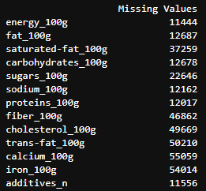
Figure 3.13: Missing values in the selected nutritional features.

b) Handling Missing Values
After identifying the missing values, records containing incomplete information in the selected nutritional features and target variable were removed using the dropna() function. Removing incomplete records ensures that the Machine Learning algorithms are trained using only complete and reliable observations.
The dataset retained a sufficient number of food products after removing missing values, providing adequate data for training and evaluating the prediction models.
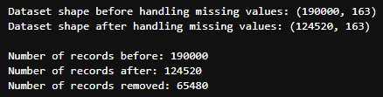
Figure 3.14: Dataset shape before and after handling missing values.

c) Removing Duplicate Records
The dataset was examined for duplicate entries using the duplicated() function to ensure that each packaged food product was represented only once. Duplicate records can introduce bias during model training by giving additional importance to repeated observations.
Any duplicate records identified during the analysis were removed, resulting in a cleaner dataset suitable for Machine Learning model development.
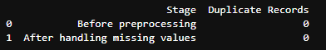
Figure 3.15: Duplicate record analysis.

d) Selecting Relevant Features
The original Open Food Facts dataset contains approximately 163 attributes, many of which are not directly relevant to nutritional quality prediction. To reduce the dimensionality of the input data and provide the Machine Learning models with relevant nutritional information, a subset of nutritional attributes was selected based on their relevance to food composition and their suitability for nutrition-grade classification.
The selected input features are Energy, Fat, Saturated Fat, Carbohydrates, Sugars, Sodium, Protein, Fiber, Cholesterol, Trans Fat, Calcium, Iron, and Additives Count.
The target variable is:
- Nutrition Grade (nutrition_grade_fr)
The selected features represent different aspects of the nutritional composition of packaged food products, including energy content, macronutrients, nutrients commonly considered in nutritional profiling, micronutrients, and additive information. Using a focused set of relevant attributes reduces unnecessary data processing while retaining the nutritional information required for predicting the nutrition grade.
e) Encoding the Target Variable
The target variable, Nutrition Grade, originally consists of categorical values ranging from A to E. Since Machine Learning algorithms require numerical data for training, the categorical grades were converted into numerical labels using Label Encoding.
The encoding process transforms the nutrition grades into numerical values while preserving their unique class representation, enabling the classification algorithms to predict the nutrition grade of packaged food products effectively.
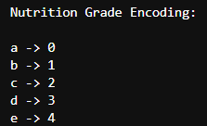
Figure 3.16: Label encoding of the nutrition grade.

f) Preparing Data for Model Training
After preprocessing, the selected nutritional features were assigned as the input variables (X), while the encoded nutrition grade served as the target variable (y). The dataset was then divided into training and testing subsets using the train_test_split() function to evaluate the performance of the Machine Learning models on unseen data.
Preparing separate training and testing datasets helps assess the generalization capability of the models and prevents overfitting.
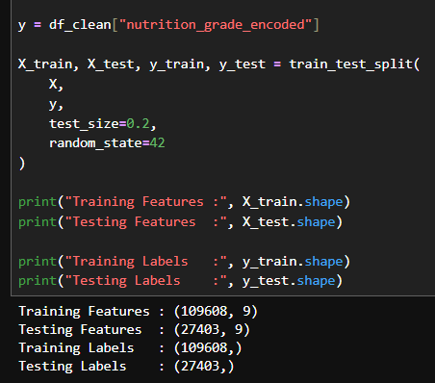
Figure 3.17: Training and testing dataset preparation.
3.2.2 Analysis of Feature Variables
The selected input variables were analyzed to understand their statistical characteristics, distributions, relationships, and suitability for Machine Learning classification. The analysis was performed on the cleaned dataset containing 123,938 food products. The final feature set consists of 13 nutritional attributes: energy, fat, saturated fat, carbohydrates, sugars, sodium, protein, fibre, cholesterol, trans fat, calcium, iron, and number of additives.
The descriptive statistics showed considerable variation among the nutritional attributes. Energy had a mean value of approximately 1216.97 kJ/100 g, while the mean values of fat, saturated fat, carbohydrates, sugars, protein, and fibre were approximately 13.44, 4.72, 35.68, 15.38, 7.98, and 2.88 g/100 g, respectively. The mean number of additives was approximately 2.06 per product.
The feature distributions showed that most nutritional variables were right-skewed, with a large number of products having relatively low values and a smaller number having higher values. This pattern was particularly visible for fat, saturated fat, sugars, protein, fibre, sodium, cholesterol, trans fat, calcium, iron, and additive count. Carbohydrates showed a comparatively wider distribution across its range. These distributions were considered during preprocessing and model development.
Correlation analysis was performed to identify relationships between the selected features. The strongest positive correlation was observed between energy and fat (r = 0.77), followed by fat and saturated fat (r = 0.69) and carbohydrates and sugars (r = 0.63). These relationships are consistent with the nutritional composition of food products. A weak negative correlation was observed between protein and sugars (r = −0.28). No extremely strong correlation was observed that would indicate severe redundancy among the selected attributes.
The relationship between the nutritional features and the target nutrition grade was also examined by comparing their mean values across Grades A–E. Several features showed clear differences between the grades. For example, mean fat increased from 2.56 g/100 g for Grade A to 27.08 g/100 g for Grade E, while saturated fat increased from 0.29 to 13.67 g/100 g. Similarly, mean sugar increased from 3.34 g/100 g in Grade A to 26.91 g/100 g in Grade E. Additive count also generally increased toward the lower nutrition grades. Fibre showed an opposite tendency, with Grade A having a higher mean fibre content than Grade E.
These observations indicate that the nutrition grade is associated with a combination of nutritional attributes rather than a single feature. Therefore, the 13 selected variables provide a multidimensional representation of the nutritional composition of packaged food products and were retained as input variables for the classification models.

3.2.3 Analysis of Class Variables
The class variable represents the output that the Machine Learning models are trained to predict. In the proposed Nutrition Risk Analyzer, the target variable is nutrition_grade_fr, which classifies packaged food products into five nutrition grades based on their overall nutritional quality.
The nutrition grades range from A to E, where Grade A represents the healthiest products with the highest nutritional quality, while Grade E represents products with the lowest nutritional quality. These grades are assigned based on the nutritional composition of the food product and serve as the labels for supervised Machine Learning.
The target variable is categorical in nature and was converted into numerical values using Label Encoding before model training. This transformation enables the Machine Learning algorithms to process the target labels effectively while preserving the distinction between the different nutrition grade classes.
Nutrition Grade Categories
Nutrition Grade | Description
A | Excellent nutritional quality
B | Good nutritional quality
C | Moderate nutritional quality
D | Poor nutritional quality
E | Very poor nutritional quality
Table 3.2: Nutrition grade categories used as the target variable.
Distribution of the Class Variable
The distribution of the nutrition grades was analysed to understand the number of food products belonging to each category. Analysing the class distribution helps determine whether the dataset is balanced and ensures that the Machine Learning models are trained on a representative set of nutrition grades.
Nutrition grade distribution:
D - 35364
C - 24971
E - 24468
A - 20056
B - 19079

3.3 Analysis of Architecture and Algorithms
The proposed Nutrition Risk Analyzer follows a Machine Learning-based architecture that predicts the nutrition grade of packaged food products using their nutritional information. The system processes the nutritional attributes entered by the user, applies data preprocessing techniques, and uses trained Machine Learning models to predict the corresponding nutrition grade. The predicted grade is then converted into a personalized nutrition risk category based on the user's age.
The overall architecture consists of the following stages:
- Data Collection
- Data Preprocessing
- Feature Selection
- Model Training
- Nutrition Grade Prediction
- Age-Based Risk Classification
- Display of Prediction Results
This architecture ensures that the system provides accurate and personalized nutrition risk assessments while maintaining computational efficiency.
3.3.1 Detailed Study Report of the Proposed Algorithms
3.3.1.1 Decision Tree
Introduction
Decision Tree is a supervised Machine Learning algorithm used for both classification and regression tasks. It predicts the target class by repeatedly dividing the dataset into smaller subsets based on the values of the input features. The algorithm represents the decision-making process as a tree structure consisting of a root node, internal decision nodes, branches, and leaf nodes. Each decision node evaluates a specific feature, while each leaf node represents the final predicted class.
Mathematical Concept
Decision Trees commonly use Gini Impurity to determine the best feature for splitting the dataset.
$$Gini=1-\sum_{i=1}^{n}{p_{i}^{2}}$$
Where:
- $p_{i}$= probability of class i
- Lower Gini value indicates better separation of classes.
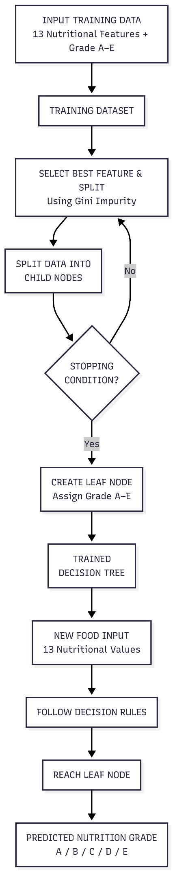
Figure 3.18: Flowchart of Decision Tree Algorithm
Step-by-Step Explanation of the Working of the Algorithms
Step 1: The model receives the 13 selected nutritional features: Energy, Fat, Saturated Fat, Carbohydrates, Sugars, Sodium, Protein, Fiber, Cholesterol, Trans Fat, Calcium, Iron, and Additives Count.
Step 2: The algorithm examines the available features and identifies the feature and threshold that best separates the nutrition-grade classes.
Step 3: The selected feature is used to create a decision such as whether a nutritional value is below or above a particular threshold.
Step 4: The dataset is divided into smaller groups based on the selected condition. The process is repeated for the resulting groups.
Step 5: Additional features and thresholds are selected to further separate the classes. This continues until the stopping conditions of the tree are reached.
Step 6: The final nodes, called leaf nodes, contain the predicted nutrition grade. The product is classified into one of the five classes: A, B, C, D, or E.
Step 7: The predicted grade is passed to the application's age-based risk classification system, which produces a Low, Moderate, or High Nutrition Risk result.
Why Decision Tree is Suitable
Decision Tree is suitable for this project because the nutritional features are numerical and can be divided into meaningful decision rules. The model learns simple threshold-based rules from the nutritional attributes to classify food products into nutrition grades (A–E). It is also highly interpretable, making it easy to understand how different nutritional values contribute to the final prediction.
3.3.1.2 Random Forest
Introduction
Random Forest is a supervised Machine Learning algorithm used for both classification and regression problems. It is an ensemble learning technique that combines the predictions of multiple Decision Trees to improve classification accuracy and reduce overfitting. Instead of relying on a single decision tree, Random Forest constructs numerous trees using different subsets of the training data and combines their predictions through majority voting.
Mathematical Concept
For classification, the final prediction is obtained using majority voting.
$$\hat{y}=mode⁡\left(T_{1} , \left(x\right) , T_{2} , \left(x\right)…T_{n}\left(x\right)\right)$$

Where:
- $\hat{y}$= Final predicted nutrition grade
- $T_{1},T_{2},...,T_{n}$= Individual Decision Trees
- $x$= Input nutritional feature vector
- mode() = Most frequently predicted class among all trees

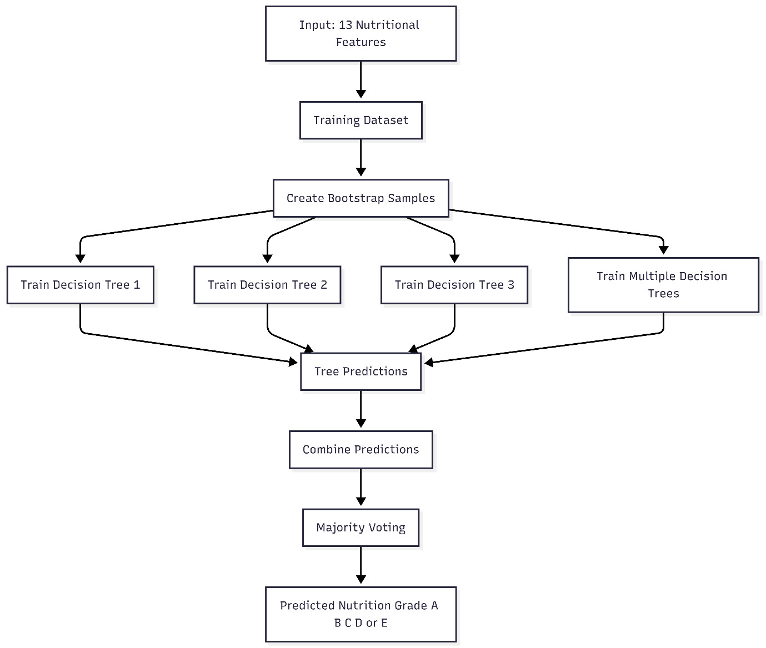
Figure 3.19: Flowchart of Random Forest Algorithm

Why Random Forest is Suitable
Random Forest is highly suitable for this project because the selected nutritional attributes exhibit complex relationships that cannot always be represented by a single Decision Tree. By combining multiple Decision Trees, Random Forest captures these relationships more effectively and improves prediction accuracy. It also handles noisy and real-world food datasets well, making it an appropriate choice for nutrition grade prediction.
Step-by-Step Explanation of the Working of the Algorithms
Step 1: The same 13 nutritional features are provided as input.
Step 2: Random Forest creates different samples of the training data for building individual Decision Trees.
Step 3: Each tree is trained using a different sample of the data and considers randomly selected subsets of features when making splits.
Step 4: Each Decision Tree independently predicts the nutrition grade of the food product.
Step 5: The predictions from all the trees are combined. For classification, the class receiving the strongest overall vote is selected as the final prediction.
Step 6: The Random Forest produces one of the five nutrition grades: A, B, C, D, or E.
Step 7: The predicted nutrition grade and the user's age group are passed to the rule-based risk assessment stage to determine Low, Moderate, or High Nutrition Risk.

3.3.1.3 Logistic Regression
Introduction
Logistic Regression is a supervised Machine Learning algorithm primarily used for classification problems. It predicts the probability that an input belongs to a particular class by applying the logistic (sigmoid) function to a linear combination of the input features. For problems involving multiple classes, such as nutrition grade prediction, Logistic Regression uses a multiclass extension to classify observations into one of several categories.
Mathematical Concept
The Logistic Regression model estimates the probability using the sigmoid function:
$$P\left(y\right)=\frac{1}{1+e^{-z}}$$
where
$$z=β_{0}+β_{1}x_{1}+β_{2}x_{2}+⋯+β_{n}x_{n}$$
Where:
- $P\left(y\right)$= Predicted probability
- $β_{0}$= Intercept
- $β_{1},β_{2},…,β_{n}$= Feature coefficients
- $x_{1},x_{2},…,x_{n}$= Nutritional feature values
For multiclass prediction, the class with the highest probability is selected as the final nutrition grade.

Why Logistic Regression is Suitable
Logistic Regression is suitable for this project because the selected nutritional attributes are structured numerical features. It provides a computationally efficient baseline model for predicting nutrition grades and allows comparison with more advanced algorithms such as Decision Tree and Random Forest. Evaluating Logistic Regression alongside the other models helps determine which algorithm provides the highest prediction accuracy.

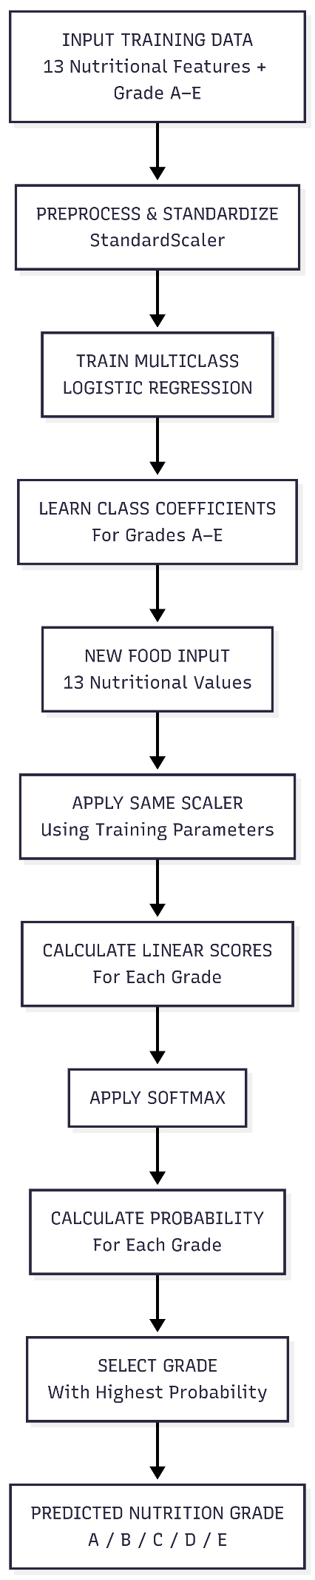
Figure 3.20: Flowchart of Logistic Regression Algorithm

Step-by-Step Explanation of the Working of the Algorithms
Step 1: The 13 nutritional features are provided to the model.
Step 2: Because the features have different numerical ranges, the input features are standardized using StandardScaler before training the Logistic Regression model.
Step 3: The model uses the standardized nutritional values to calculate the probability of the product belonging to each nutrition grade.
Step 4: The probabilities for the five classes are compared.
Step 5: The class with the highest predicted probability is selected as the nutrition grade.
Step 6: The model produces one of the five classes: A, B, C, D, or E.
Step 7: The predicted nutrition grade is combined with the user's age group using the predefined rules to produce the final Low, Moderate, or High Nutrition Risk.

3.3.2 Activity Diagram
The activity diagram illustrates the overall workflow of the proposed Nutrition Risk Analyzer. It represents the sequence of operations performed from loading the dataset to generating the final nutrition risk prediction. The diagram shows the interaction between data preprocessing, model training, nutrition grade prediction, and age-based risk classification.
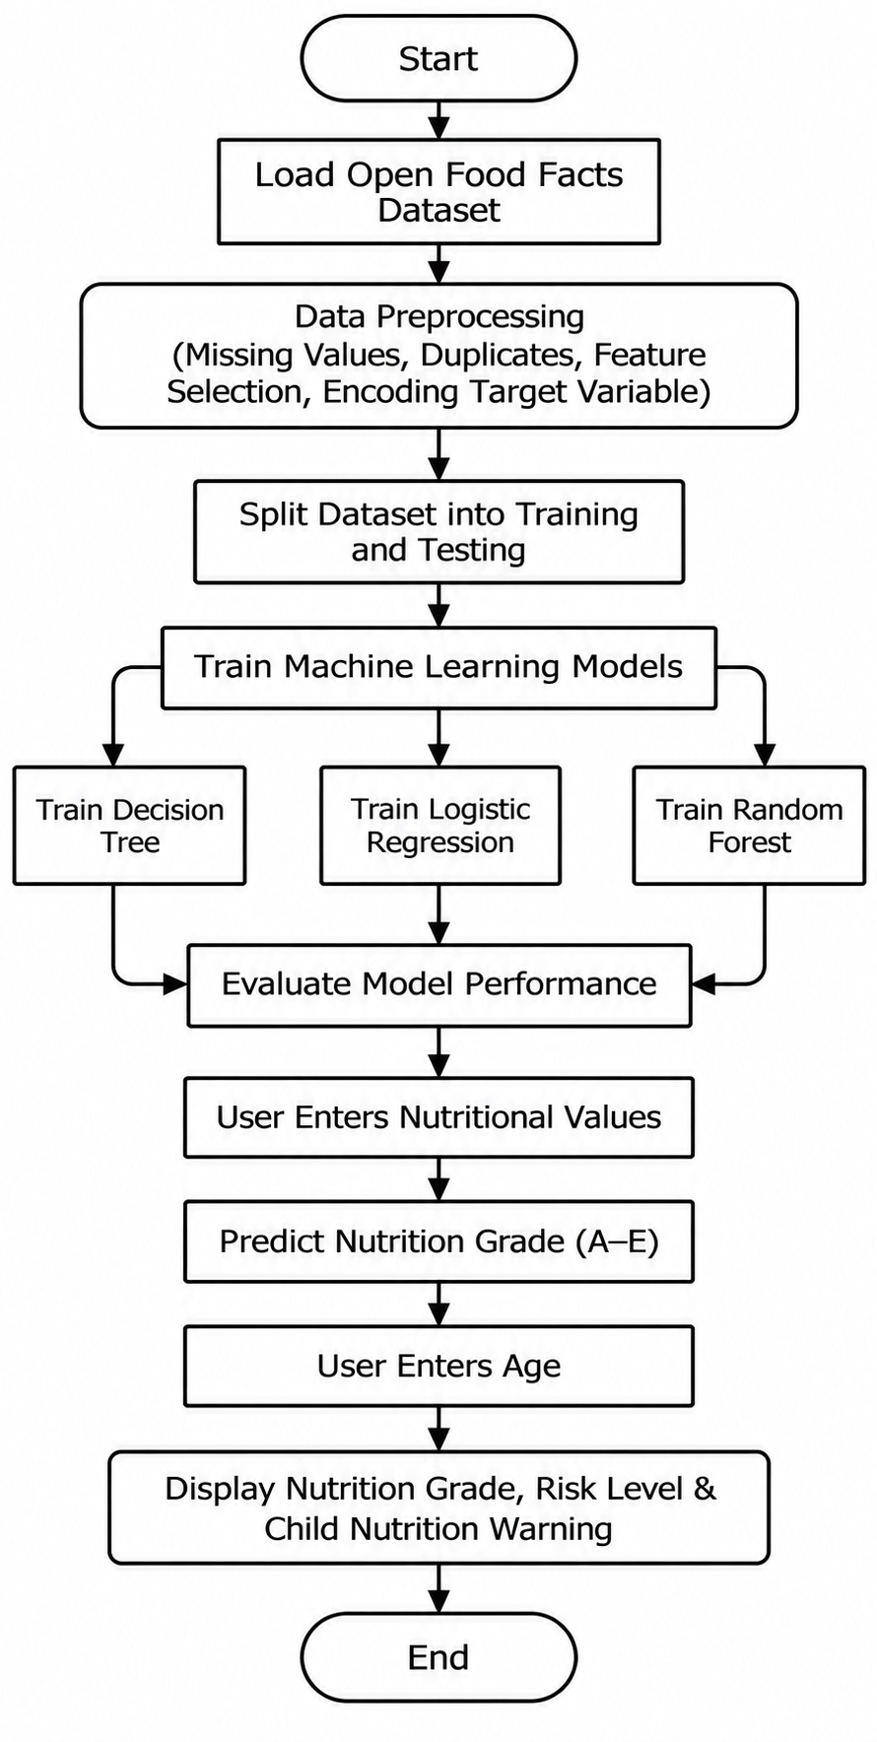
Figure 3.21: Activity diagram of the proposed Nutrition Risk Analyzer.
3.3.3 Step-by-Step Explanation of the Working of the Proposed System
The proposed Nutrition Risk Analyzer follows a systematic workflow to predict the nutritional quality of packaged food products. The working process consists of the following steps:
- Collect the Open Food Facts dataset containing nutritional information of packaged food products.
- Select the relevant nutritional features and target variable.
- Perform data preprocessing by handling missing values, removing duplicate records, and preparing the dataset for training.
- Encode the target variable (nutrition grade) into numerical values.
- Split the dataset into training and testing sets.
- Train the Decision Tree, Random Forest, and Logistic Regression models using the training data.
- Evaluate the performance of the trained models and select the best-performing model.
- Deploy the selected model within the web application.
- Accept nutritional information entered by the user.
- Predict the nutrition grade (A–E) using the trained Machine Learning model.
- Accept the user's age.
- Apply the age-based nutrition risk mapping.
- Display the predicted nutrition grade and the corresponding nutrition risk level to the user.

3.4 Project Pipeline
Introduction
The project pipeline illustrates the complete workflow of the proposed Nutrition Risk Analyzer, beginning with data collection and ending with the prediction of nutrition grade and personalized nutrition risk. Each stage of the pipeline performs a specific function to ensure that the data is properly prepared, the Machine Learning models are accurately trained, and reliable predictions are generated for users.

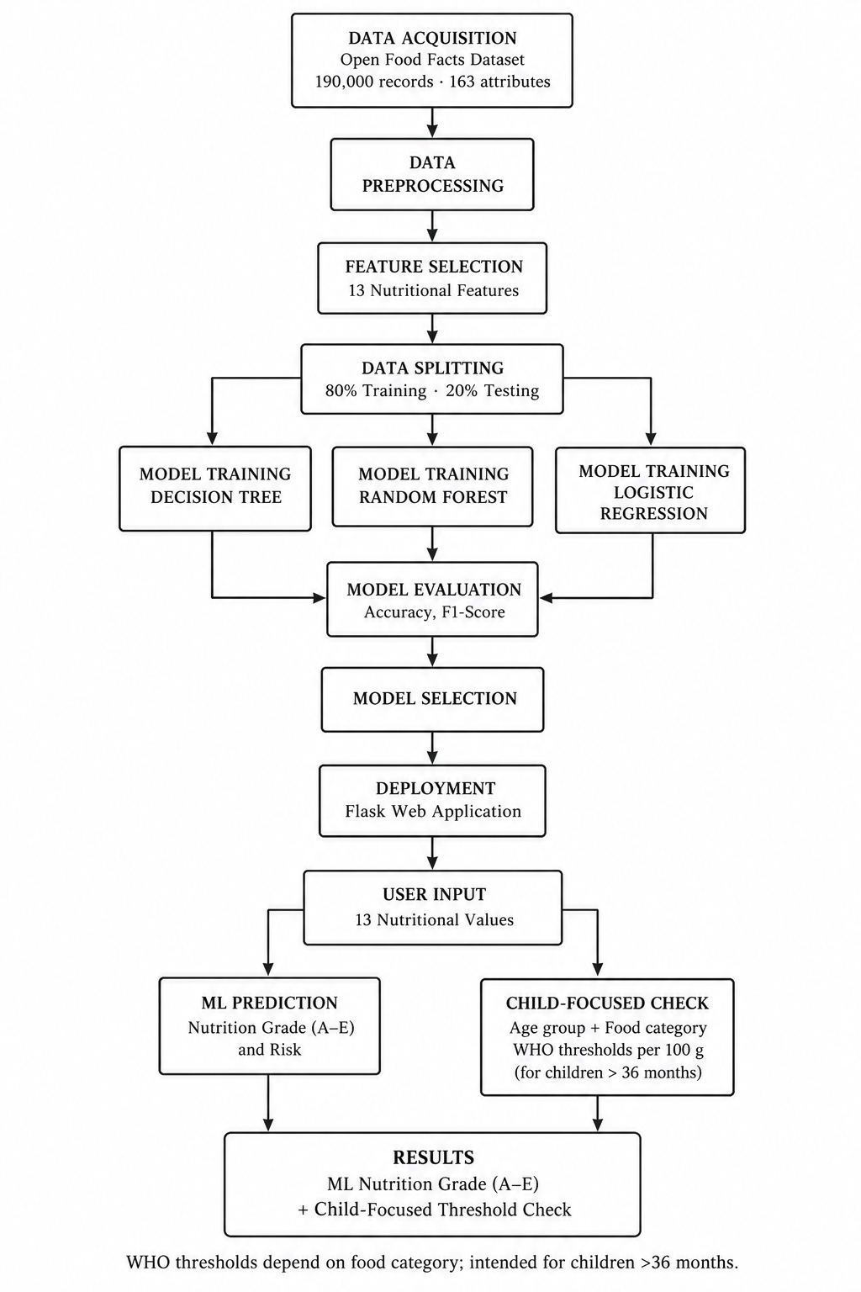
Figure 3.22: Project pipeline of the proposed Nutrition Risk Analyzer.
1. Dataset Collection
The Open Food Facts dataset is collected and used as the primary source of nutritional information for packaged food products.

2. Data Preprocessing
The dataset undergoes preprocessing to remove missing values, eliminate duplicate records, encode the target variable, and prepare the data for Machine Learning.

3. Feature Selection
13 nutritional attributes are selected as input features:

4. Model Training
Three Machine Learning algorithms are trained using the prepared dataset:
- Decision Tree
- Random Forest
- Logistic Regression

5. Model Evaluation
The trained models are evaluated using performance metrics such as:
- Accuracy
- Precision
- Recall
- F1-Score

6. Best Model Selection
The model with the highest prediction performance is selected and used for deployment in the application.

7. User Input
The user enters the nutritional values of a packaged food product through the web application.

8. Nutrition Grade Prediction
The trained Machine Learning model predicts the nutrition grade (A–E) based on the nutritional values provided by the user.

9. Age-Based Risk Mapping
The predicted nutrition grade is combined with the user's age group to determine the personalized nutrition risk category using predefined mapping rules.

10. Result Display
The system displays:
- Predicted Nutrition Grade
- Nutrition Risk Category
This helps users understand the nutritional quality of the food product and make informed dietary decisions.

3.6 Feasibility Analysis
The feasibility analysis evaluates whether the proposed Nutrition Risk Analyzer can be successfully developed, implemented, and maintained using the available resources, technology, budget, and time. It assesses the practicality of the project from technical, economic, operational, legal, and scheduling perspectives.

3.6.1 Technical Feasibility
The proposed Nutrition Risk Analyzer is technically feasible because it is developed using widely adopted open-source technologies and Machine Learning libraries. The project utilizes the Open Food Facts dataset for model training and employs Decision Tree, Random Forest, and Logistic Regression algorithms for nutrition grade prediction. Python is used for data preprocessing and model development, while Flask is used to develop the web interface and handle user interaction. The required software tools, including Pandas, NumPy, Scikit-learn, Matplotlib, Joblib, and Flask, are freely available and compatible with standard personal computers. Therefore, no specialized hardware or proprietary software is required to implement the proposed system.

3.6.2 Economic Feasibility
The proposed system is economically feasible because it is developed using free and open-source software. The Open Food Facts dataset is publicly available, eliminating the need to purchase a commercial dataset. Python, Flask, and the Machine Learning libraries used in the project are open source and do not require additional licensing costs. Consequently, the overall development cost is minimal, making the project affordable for academic and small-scale deployment purposes.

3.6.3 Operational Feasibility
The proposed Nutrition Risk Analyzer is easy to operate and requires minimal technical knowledge from users. The application provides a simple interface where users enter nutritional values and their age to receive the predicted nutrition grade and personalized nutrition risk. The automated prediction process reduces manual effort and delivers results within a short time. The straightforward workflow enhances usability and supports informed food choices for users.

3.6.4 Legal Feasibility
The project uses the Open Food Facts dataset, which is publicly available for research and educational purposes. The software libraries employed in the project are open source and distributed under their respective licenses. The application processes only the nutritional values and the user's age during prediction and does not store or disclose sensitive personal information. Therefore, the project complies with ethical and legal considerations for academic use.

3.6.5 Schedule Feasibility
The project can be completed within the allocated academic timeline. The development process includes dataset collection, data preprocessing, exploratory data analysis, model training, model evaluation, web application development, testing, and documentation. Since all required tools and datasets are readily available, the project can be implemented without significant delays, making it feasible within the planned project schedule.

3.7 System Environment
The system environment describes the software and hardware requirements necessary to develop, train, test, and run the ML-Based Packaged Food Nutrition Risk Analyzer. The environment consists of the software tools, programming languages, libraries, and hardware resources used for implementing the application.

3.7.1 Software Environment
The software environment includes the programming language, development tools, libraries, and frameworks used to develop the application and implement the machine learning models.
Software / Technology | Purpose
Python | Main programming language for data preprocessing, model development, and application logic.
Flask | Web framework used to develop the web application.
Pandas | Data loading, cleaning, manipulation, and preprocessing.
NumPy | Numerical operations and data processing.
Scikit-learn | Implementation, training, and evaluation of Decision Tree, Random Forest, and Logistic Regression models.
Matplotlib / Seaborn | Exploratory data analysis and visualization of nutritional data.
Joblib | Saving and loading the trained machine learning model.
Jupyter Notebook | Data analysis, feature selection, model training, and evaluation.
HTML and CSS | Designing and styling the web application's user interface.
Web Browser | Accessing and interacting with the web application.
Table 3.3: Software / Technology Requirements
The application uses the Open Food Facts dataset for nutritional data and applies classical machine learning algorithms to predict the nutrition grade of packaged food products.

3.7.2 Hardware Environment
The hardware environment describes the physical resources required to develop and execute the application. Since the project uses classical machine learning algorithms, it can run on a standard computer without requiring a dedicated GPU.
Component | Requirement
Processor | Intel Core i3 or equivalent processor, or higher
RAM | Minimum 4 GB; 8 GB or more recommended
Storage | Sufficient disk space for the dataset, source code, libraries, and saved model
Display | Standard monitor or laptop display
Input Devices | Keyboard and mouse or touchpad
Internet Connection | Required for downloading datasets and installing dependencies; also needed for online access if applicable
Table 3.4: Hardware Requirements
The system can be executed on a standard laptop or desktop computer. The processor and memory requirements depend on the size of the dataset and the number of records processed during training. A dedicated graphics processing unit (GPU) is not required for the selected machine learning algorithms.

4. System Design
The system design describes the architecture and implementation of the ML-Based Packaged Food Nutrition Risk Analyzer. The system uses nutritional data from the Open Food Facts dataset to train machine learning models that predict the nutrition grade of packaged food products.
The system development involves data preprocessing, feature selection, dataset splitting, model training, testing, and performance evaluation. Three machine learning algorithms—Decision Tree, Random Forest, and Logistic Regression—are implemented and compared. The model with the best test-set performance is selected for integration into the web application.
4.1 Models Building
The model-building phase involves developing and evaluating machine learning models using the selected nutritional features. The target variable is nutrition_grade_fr, which represents the nutrition grade from A to E.
The following algorithms are used:
- Decision Tree Classifier: A tree-based model that predicts grades using feature-based decision rules.
- Random Forest Classifier: An ensemble model that combines multiple decision trees to produce a prediction.
- Logistic Regression: A linear classification model used as a baseline for comparison.
Random Forest is selected as the final model based on its highest test-set accuracy of 95.90%.
4.1.1 Implementation Code
The project is implemented using Python and the Scikit-learn library. Pandas and NumPy are used for data handling, while Scikit-learn is used for dataset splitting, feature scaling, model training, and evaluation.
The following code illustrates the implementation of the three classification models.
# Import required libraries
from sklearn.model_selection import train_test_split
from sklearn.preprocessing import StandardScaler
from sklearn.tree import DecisionTreeClassifier
from sklearn.ensemble import RandomForestClassifier
from sklearn.linear_model import LogisticRegression
# Define input features and target
X = df[features]
y = df["nutrition_grade_fr"]
# Split the dataset into training and testing sets
X_train, X_test, y_train, y_test = train_test_split(
X, y,
test_size=0.20,
random_state=42,
stratify=y
)
# Standardize features for Logistic Regression
scaler = StandardScaler()
X_train_scaled = scaler.fit_transform(X_train)
X_test_scaled = scaler.transform(X_test)
# Initialize models
dt_model = DecisionTreeClassifier(random_state=42)
rf_model = RandomForestClassifier(
n_estimators=100,
random_state=42,
n_jobs=-1
)

lr_model = LogisticRegression(max_iter=1000)
# Train models
dt_model.fit(X_train, y_train)
rf_model.fit(X_train, y_train)
lr_model.fit(X_train_scaled, y_train)

The code defines the 13 nutritional features as input (X) and the nutrition grade as the target (y). The dataset is split into 80% training and 20% testing data. StandardScaler is used to standardize features for Logistic Regression. Finally, Decision Tree, Random Forest, and Logistic Regression models are initialized and trained using the training data.

4.1.2 Model Planning (Training/Testing Split of the Dataset)
The cleaned dataset consists of 123,938 records. The dataset is divided into training and testing sets using an 80:20 ratio.
An 80% portion of the data is used to train the models, while the remaining 20% is reserved for testing their performance on unseen data.
The train_test_split() function from Scikit-learn is used with random_state=42 to ensure reproducibility. Stratified splitting is applied to preserve the approximate distribution of the nutrition grades A–E in both sets.
Dataset | Number of Records | Percentage
Training set | 99,150 | 80%
Testing set | 24,788 | 20%
Total | 123,938 | 100%
Table 4.1: Distribution of Training and Testing Dataset
4.1.3 Training — Build the Model Using the Training Dataset
During the training phase, Decision Tree, Random Forest (100 trees), and Logistic Regression are trained on the training dataset to learn patterns between nutritional features and nutrition grades (A–E). Logistic Regression uses standardized features, while the other two models use the original feature values.
The following code demonstrates the training process:
# Train Decision Tree
dt_model.fit(X_train, y_train)

# Train Random Forest
rf_model.fit(X_train, y_train)

# Train Logistic Regression using standardized features
lr_model.fit(X_train_scaled, y_train)

Random Forest is trained using the original, unscaled feature values, while Logistic Regression uses the standardized features. The trained models are then used to predict the nutrition grades of the test dataset.

4.1.4 Testing — Evaluate the Performance of the Model Using the Test Dataset
The testing phase evaluates the performance of the trained models using the 20% test dataset, which was not used during training.
Each model predicts the nutrition grades of the test records. The predicted grades are compared with the actual grades to calculate evaluation metrics.
The following metrics are used:
- Accuracy: Measures the proportion of correctly predicted grades.
- Precision: Measures the correctness of the model's positive predictions for each class.
- Recall: Measures how many actual instances of each grade are correctly identified.
- F1-Score: Represents the harmonic mean of precision and recall.

Model Evaluation Code
from sklearn.metrics import (
accuracy_score,
precision_score,
recall_score,
f1_score,
classification_report,
confusion_matrix
)
# Generate predictions
y_pred_dt = dt_model.predict(X_test)
y_pred_rf = rf_model.predict(X_test)
y_pred_lr = lr_model.predict(X_test_scaled)

# Store predictions
predictions = {
"Decision Tree": y_pred_dt,
"Random Forest": y_pred_rf,
"Logistic Regression": y_pred_lr
}
# Evaluate all models
for name, y_pred in predictions.items():
print("\n", name)
print("Accuracy :", accuracy_score(y_test, y_pred))
print("Precision:", precision_score(
y_test, y_pred, average="weighted"
))
print("Recall :", recall_score(
y_test, y_pred, average="weighted"
))
print("F1-Score :", f1_score(
y_test, y_pred, average="weighted"
))
The code generates predictions for the testing dataset using all three models and stores them in a dictionary. It then evaluates each model using Accuracy, Precision, Recall, and F1-Score with weighted averaging to compare their classification performance.

Model Performance Results
The evaluation results obtained from the test dataset are summarized below.

Model | Accuracy | Precision | Recall | F1-Score
Decision Tree | 94.83% | 94.83% | 94.83% | 94.83%
Random Forest | 95.90% | 95.90% | 95.90% | 95.90%
Logistic Regression | 71.68% | 72.14% | 71.68% | 71.74%
Table 4.2: Performance Comparison of Machine Learning Models

Random Forest achieved the highest test accuracy of 95.90%, demonstrating the strongest overall performance among the three evaluated models on this test set. Therefore, it was selected as the final model for integration into the web application.

4.2. Age-Based Nutritional Analysis
This section uses nutritional guidelines and recommended nutrient limits from the World Health Organization (WHO) to evaluate the nutritional content of packaged food products. Based on the selected age group and product category, the system compares the nutrient quantities with the applicable recommended limits. The output identifies which nutrients exceed the recommended limits and which remain within the limits, helping users better understand the nutritional suitability of the product.
No. | Food category | Total fat (g) | Saturated fat (g) | Total sugars (g) | Added sugars (g) | Sodium (g) | Energy (kcal)
1 | Confectionery | 8.0 | — | 6.0 | — | — | 230
2 | Fine bakery wares | 8.0 | — | 6.0 | — | 0.25 | 230
3 | Bread and ordinary bakery wares | 8.0 | — | 6.0 | — | 0.25 | —
4 | Cereals | 12.0 | — | 9.0 | — | 0.35 | —
5a | Ready-to-eat savoury snacks (potato, cereal, starch-based and animal-skin snacks) | 8.0 | — | — | 0.0 | 0.25 | 230
5b | Processed nuts | — | — | — | 0.0 | 0.05 | —
5c | Fish-based snacks | — | — | 6.0 | — | 0.25* | 230
6a | Fruit and vegetable juices | — | — | 6.0 | 0.0 | — | —
6b | Milk and dairy-based drinks | 7.0 | — | — | 0.0 | — | —
6c | Water-based flavoured drinks | — | — | 2.0 | — | 0.30 | —
6d | Coffee, tea and herbal infusions | — | — | 2.0 | — | — | —
6e | Cereal, grain and tree nut-based beverages | — | — | 6.0 | — | 0.20 | —
7 | Frozen dairy-based desserts and edible ices | 8.0 | — | 12.0 | — | 0.10 | 230
8 | Curded dairy-based desserts | 7.0 | — | 6.0 | — | 0.10 | 230
9 | Cheese and analogues | 20.0 | — | — | 0.0 | 0.60 | —
10 | Composite foods (prepared foods) | 8.0 | 3.5 | 9.0 | — | 0.35 | —
11 | Fats, oils and fat emulsions | — | 35.0 | — | — | 0.10 | —
12 | Pasta, noodles and similar products | 3.0 | — | — | — | 0.25 | —
13 | Fresh and frozen meat, poultry, game, fish and seafood | 15.0 | — | — | — | — | —
14a | Processed meat, poultry and game | 8.0 | — | — | — | 0.40 | —
14b | Processed fish and seafood | 8.0 | 3.0 | — | — | 0.40 | —
15 | Fresh and frozen fruits, vegetables and legumes | Permitted | — | — | — | — | —
16 | Processed fruits and vegetables | — | — | — | 0.0 | 0.40 | —
17 | Solid-form soybean products | 12.0 | — | 5.0 | 0.0 | 0.10 | —
18 | Sauces, dips and dressings | 12.0 | — | 10.0 | — | 0.30 | —

Table 4.3: Age-Based Nutrient Thresholds by Food Category

5. Results and Discussion
This chapter presents the results obtained from the machine learning models developed for the ML-Based Packaged Food Nutrition Risk Analyzer. It compares the performance of Decision Tree, Random Forest, and Logistic Regression using evaluation metrics, confusion matrix analysis, and predictions on unseen test data.
The results are discussed to identify the model that performs most effectively in predicting nutrition grades from A to E. The chapter also examines the classification errors, prediction statistics, and the implications of the findings for the proposed web application.

5.1 Comparison of Models
Three machine learning algorithms were evaluated using the same training and testing split. The models were compared based on their ability to predict the nutrition grade of packaged food products.
Random Forest achieved the highest accuracy, precision, recall, and F1-score among the three models. Decision Tree also demonstrated strong classification performance, while Logistic Regression achieved lower results.
These results indicate that the tree-based models captured the relationships between nutritional features and nutrition grades more effectively than the linear baseline in this experiment.

5.2 Evaluation Metrics
The models were evaluated using four standard classification metrics: accuracy, precision, recall, and F1-score.
- Accuracy: Measures the proportion of test samples correctly classified.
- Precision: Measures how many predictions for a particular grade were correct.
- Recall: Measures how many actual samples of a grade were correctly identified.
- F1-Score: Combines precision and recall into a single metric using their harmonic mean.
Random Forest achieved approximately 95.90% across all four reported metrics, indicating strong overall classification performance on the test dataset.

5.3 Confusion Matrix
A confusion matrix is used to evaluate the classification performance of the Random Forest model by comparing the actual nutrition grades with the predicted grades.
The following confusion matrix shows the number of products correctly and incorrectly classified into grades A, B, C, D, and E.

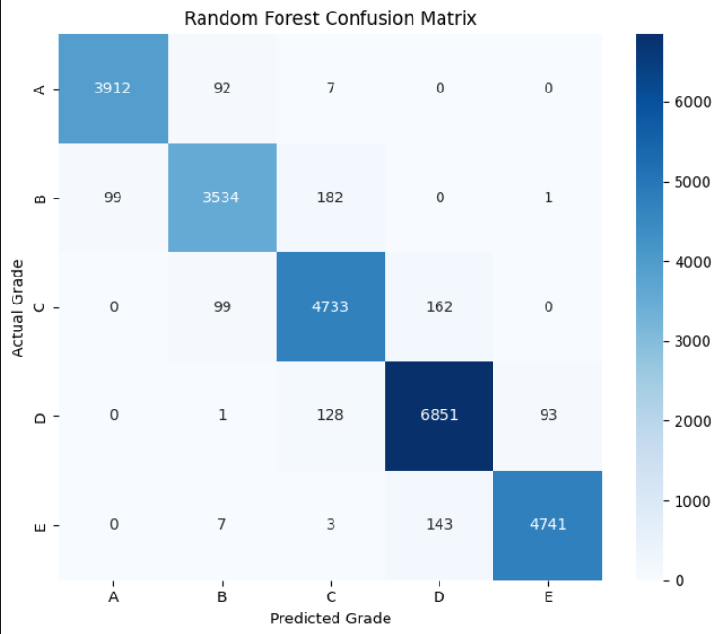
Figure 5.1: Confusion Matrix of Random Forest

Interpretation
- Most predictions fall along the diagonal, indicating that the model correctly classified the majority of products.
- Grade A and Grade E achieved high numbers of correct predictions.
- Some products were misclassified between neighboring grades, such as B and C or C and D.
- The model occasionally predicted a higher or lower grade than the actual grade.
The confusion matrix provides a more detailed understanding of the model's classification errors than accuracy alone.

5.4 Relevant Metrics Calculated from the Confusion Matrix
The confusion matrix can be used to calculate additional classification metrics for each nutrition grade.
Grade | Precision | Recall | F1-Score
A | 0.98 | 0.98 | 0.98
B | 0.95 | 0.93 | 0.94
C | 0.94 | 0.95 | 0.94
D | 0.96 | 0.97 | 0.96
E | 0.98 | 0.97 | 0.97
Table 5.1: Classification Metrics by Nutrition Grade

The results indicate that the Random Forest model performed consistently across the five nutrition grades. Grades A and E achieved particularly high precision and recall, while Grade B had comparatively lower recall. These metrics help identify how reliably the model predicts each individual grade.

5.5 Prediction Statistics of Unseen Data
The trained models were evaluated on the 24,788 records in the test dataset, which were not used during model training.
The Random Forest model produced the following prediction statistics:

Evaluation Statistic | Value
Total test records | 1000
Correct predictions | 878
Incorrect predictions | 122
Test accuracy | 87.80%
Table 5.2: Evaluation Statistics

Grade | Actual Records | Predicted Records
A (0) | 200 | 217
B (1) | 200 | 166
C (2) | 200 | 220
D (3) | 200 | 208
E (4) | 200 | 189
Total | 1000 | 1000

Table 5.3: Actual vs. Predicted Distribution

The Random Forest model was evaluated using 50 samples selected from the testing dataset. Out of 50 records, 47 were correctly predicted and 3 were misclassified, achieving an accuracy of 94%. The actual and predicted grade distributions show that the model performed consistently across all five nutrition grade classes (0–4).

5.6 Discussion of Findings
The evaluation results provide several important observations about the developed models.
- Random Forest achieved the highest performance: It obtained 95.90% test accuracy and was selected as the final model.
- Decision Tree also performed well: Its accuracy of 94.83% indicates that a single tree was able to capture many of the relationships between nutritional features and nutrition grades.
- Logistic Regression achieved lower performance: Its accuracy of 71.68% suggests that a linear classification approach was less effective at capturing the patterns in this dataset.
- Most Random Forest predictions were correct: The confusion matrix shows that 23,771 of the 24,788 test records were correctly classified.
- Some classification errors occurred between neighboring grades: This indicates that the model sometimes had difficulty distinguishing products with similar nutritional profiles.

5.7 Conclusion
The experimental results demonstrate that machine learning can be used to predict the nutrition grades of packaged food products using selected nutritional features. Among the three evaluated algorithms, Random Forest achieved the highest test-set accuracy of 95.90%, followed by Decision Tree at 94.83% and Logistic Regression at 71.68%.
Based on these results, Random Forest was selected as the final model for the proposed system. The model's predictions are used as the basis for the subsequent risk classification and age-based nutritional assessment stages of the application.
Overall, the results support the feasibility of developing a web-based system that provides automated nutrition-grade predictions from packaged food nutritional information.

6. Model Deployment
6.1 Model Implementation
The ML-Based Packaged Food Nutrition Risk Analyzer is implemented as a web-based application using Python and Flask. The trained Random Forest model is integrated into the application to predict the nutrition grade of packaged food products based on 13 selected nutritional features.
The trained model is saved as a file and loaded into the Flask application using Joblib. When the user enters the nutritional values, the application validates the input and passes the data to the model. The model predicts a nutrition grade ranging from A to E. After prediction, the system performs a separate risk assessment to classify the product into Lower, Moderate, or High Risk categories. An age-based nutritional assessment can also be performed separately using the user's age and the available nutritional information.
The application displays the predicted nutrition grade, risk category, and relevant nutritional information. This deployment makes the trained machine learning model accessible through a simple and interactive web interface.

6.2 UI Design
The user interface is designed to be simple, user-friendly, and easy to navigate. It allows users to enter the nutritional information of packaged food products and view the predicted nutrition grade and corresponding risk assessment.
The interface includes a nutritional input form containing fields for the 13 selected features. Users can enter the values manually and submit the form for prediction. The application processes the input and displays the predicted grade, risk category, and nutritional assessment.
The result page presents the prediction in a clear format, helping users understand the nutritional profile of the selected food product. The interface can also include an age input field for a separate age-based nutritional assessment.
Main UI Components
- Home Page: Introduces the application and provides access to the nutrition analysis feature.
- Input Form: Allows users to enter the required nutritional values.
- Prediction Button: Submits the input data for model prediction.
- Result Section: Displays the predicted nutrition grade (A–E) and risk category.
- Nutritional Assessment: Provides relevant nutritional observations and age-based assessment, where applicable.
The UI is developed using HTML and CSS, while Flask handles the backend processing and integration of the trained machine learning model.

1.Home Page

The home page introduces the NutriRisk application and its purpose of analyzing the nutritional risk of packaged food products. It provides navigation options and buttons to access the food analysis feature and learn more about the system.
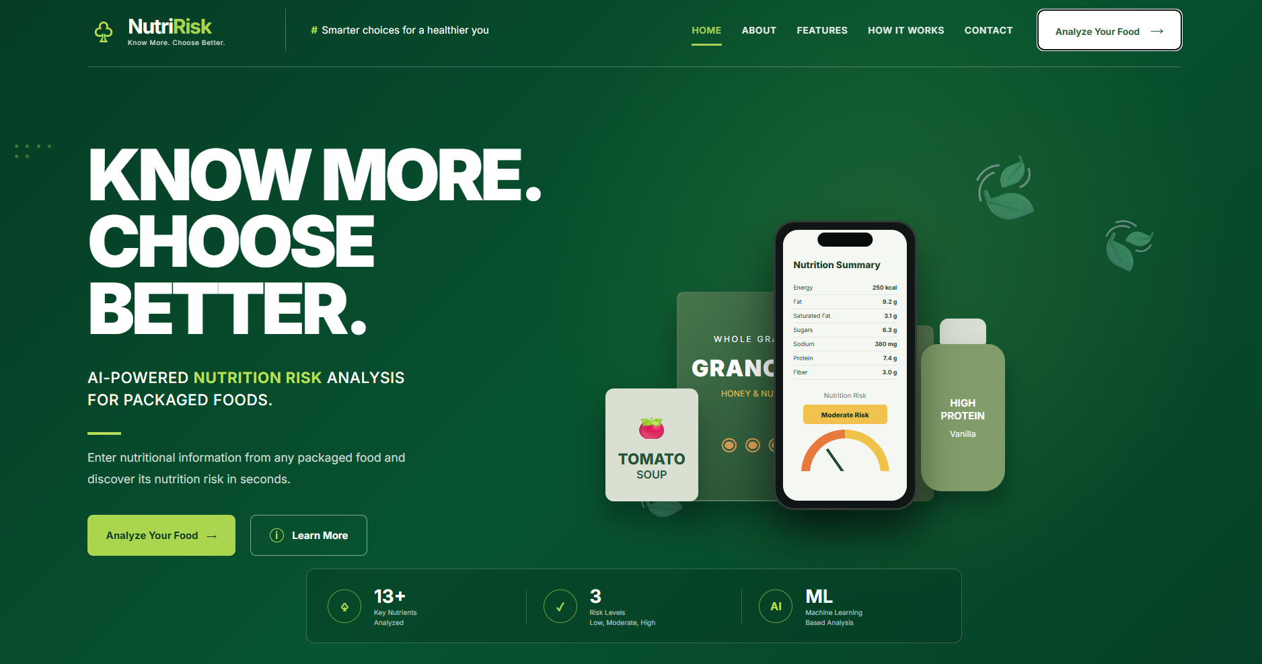
Figure 6.1: Home Page

2. Nutritional Input Form
This interface allows users to enter nutritional information from a packaged food label, including energy, fat, saturated fat, carbohydrates, sugars, sodium, protein, fiber, cholesterol, trans fat, calcium, iron, and the number of additives. The user can submit the values using the Analyze Nutrition Risk button to obtain the prediction.
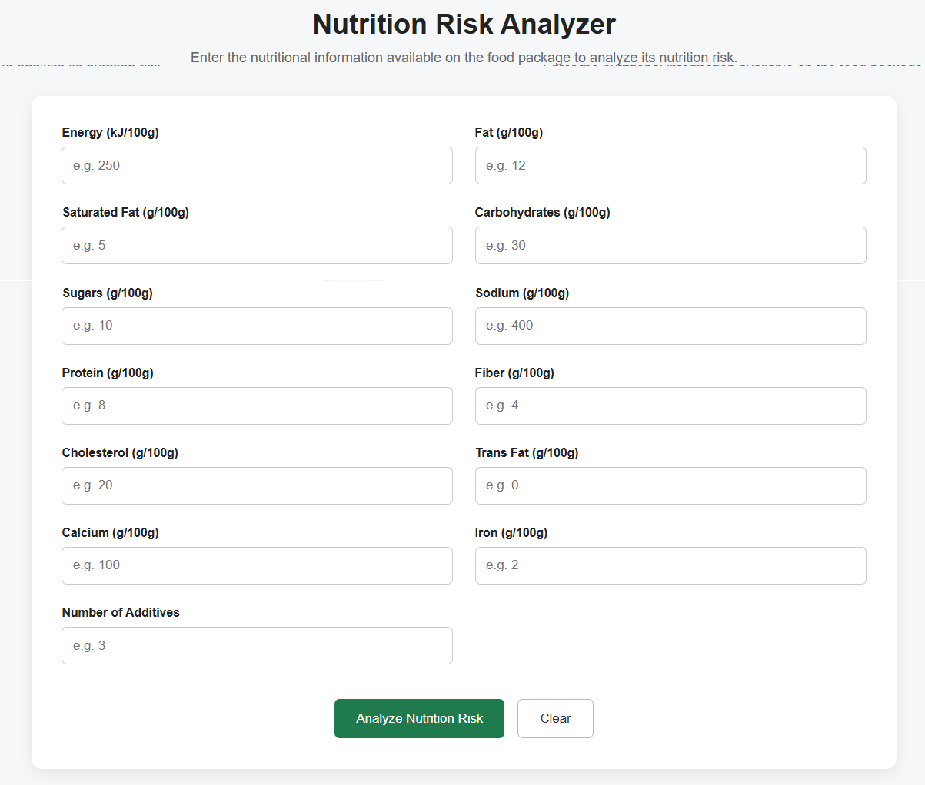
Figure 6.2 – Nutritional Input Form
3. Analysis Result Interface
This interface displays the machine learning model's predicted nutrition grade and the corresponding project risk category. It also provides a brief explanation of the prediction and displays basic food details, including the product name, nutrition input basis, and serving size.
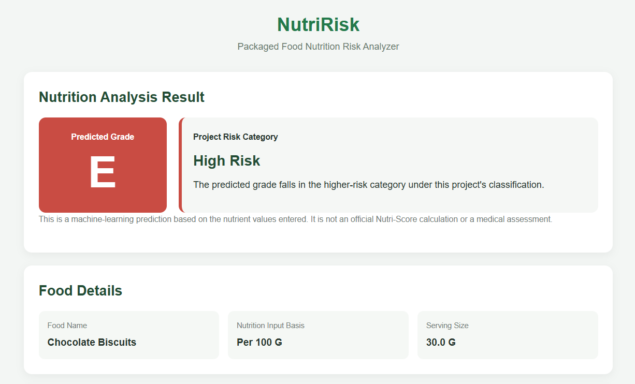
Figure 6.3 Nutrition Analysis Result Interface

4. Child-Focused Nutrition Threshold Analysis
This interface evaluates the entered nutritional values against applicable nutrient thresholds based on the WHO South-East Asia Region Nutrient Profile Model. It displays the selected food category, threshold-check status, and a table of nutrients that exceed the specified limits, helping identify products that may not meet the model's criteria for marketing to children.
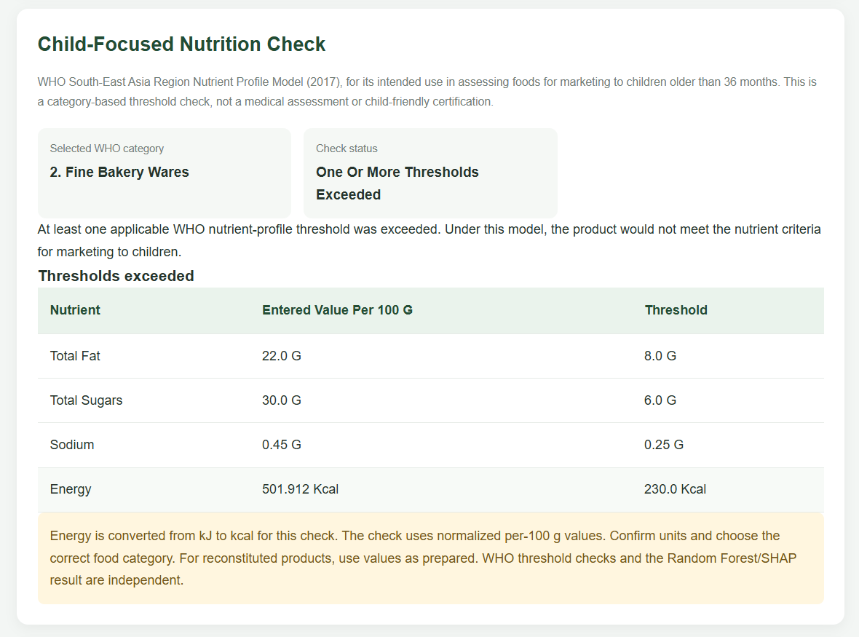
Figure 6.4: Child-Focused Nutrition Check Interface

6.Machine Learning Prediction Explanation UI
This interface explains the main factors influencing the predicted nutrition grade. It highlights important nutritional features, such as saturated fat, energy, and total fat, and indicates how they influenced the model's prediction.
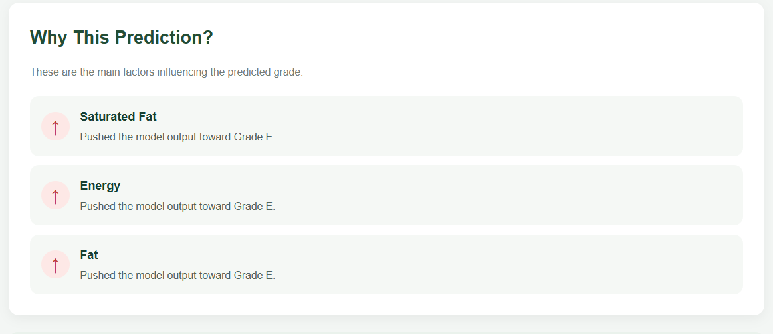
Figure 6.5: Prediction Explanation Interface

7.Git History
Git and GitHub are used for version control and repository management in the proposed ML-Based Packaged Food Nutrition Risk Analyzer (Nutrisk) system. Git helps track changes made to the project files, while GitHub provides a centralized platform for storing and managing the source code. The Nutrisk project repository contains the machine learning application, HTML templates, static resources, supporting feature files, and other essential project files.
The project was uploaded to GitHub using Git commands. The repository includes the overall project structure, the Python application, and the README documentation describing the system. The following screenshots illustrate the project repository and its main components.

7.1 Overall Project Repository
The overall project repository on GitHub displays the main folders and files of the Nutrisk application. It provides an overview of the project organization, including the Backup, Bp 2, static, and templates folders, along with the main Python application file, supporting feature file, and README documentation.
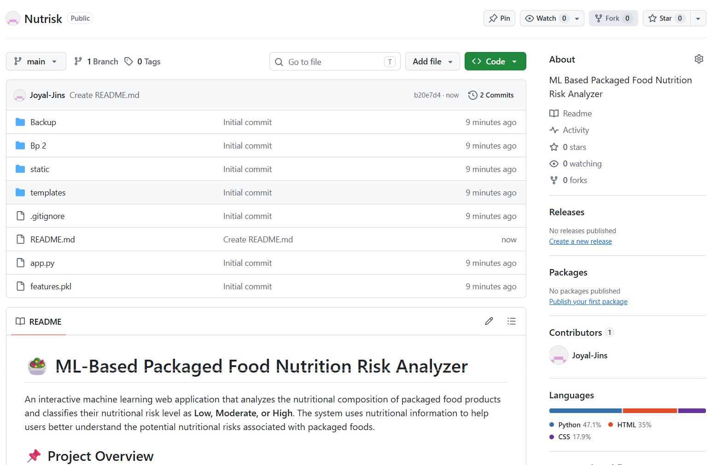
Figure 7.1: Overall Project Repository on GitHub

7.2 Project Directory Structure
The project directory structure contains the HTML templates and static resources required for the web application's user interface. The templates folder includes files such as index.html, about.html, predict.html, result.html, output.html, and base.html. These templates support the presentation of project information, nutritional input forms, and prediction results. The static folder stores resources used to style and support the web interface.

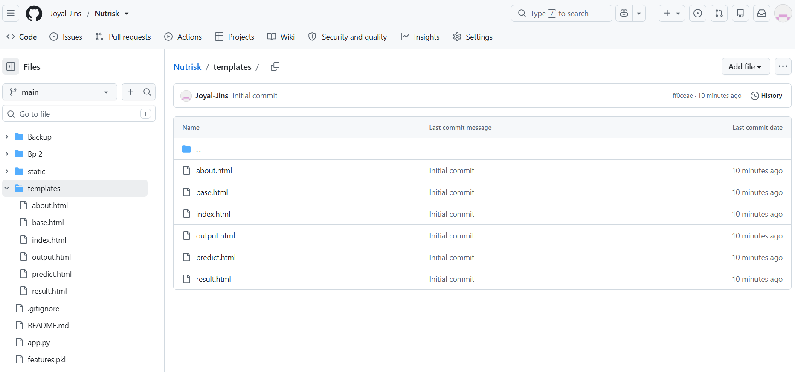
Figure 7.2: Directory Structure of the Project on GitHub
7.3 Source Code Repository
The app.py file contains the main Python application responsible for processing user inputs, loading the trained machine learning model, mapping nutritional input fields to model features, and generating nutrition risk predictions. The application also supports the display of prediction results and relevant nutritional warnings through the web interface.

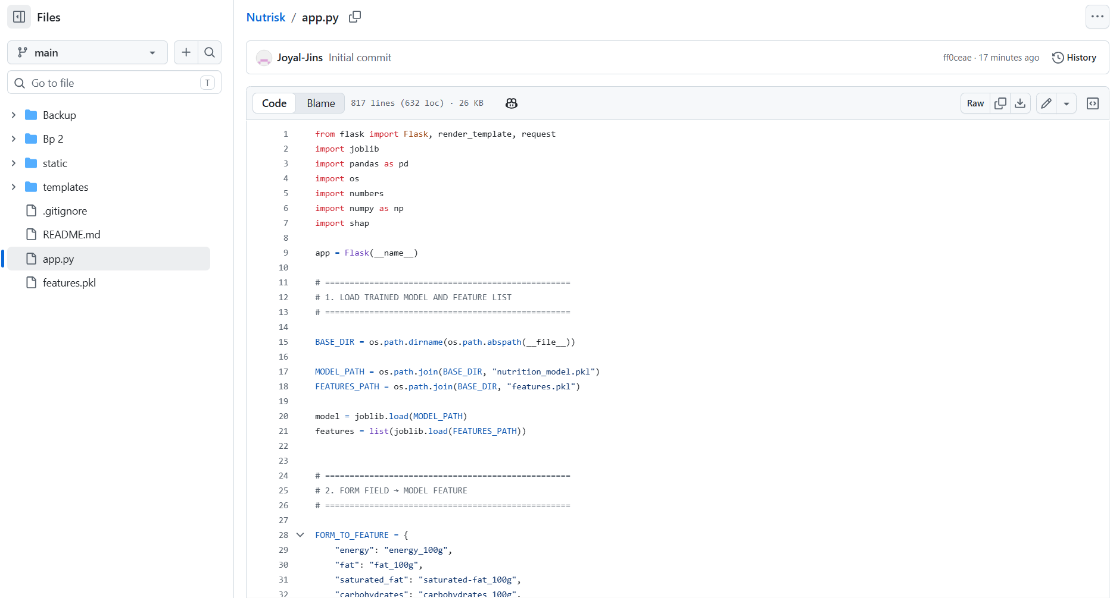
Figure 7.3: Source Code of the Application on GitHub

Overall, Git and GitHub provide an effective way to maintain the source code, organize project components, and track development changes. The repository supports future maintenance, collaboration, and further development.

8. Conclusions

The ML-Based Packaged Food Nutrition Risk Analyzer was developed to analyze the nutritional composition of packaged food products and classify their nutritional grades using machine learning.
The system uses nutritional information as input and applies a trained Random Forest model to predict a nutrition grade. Based on the predicted grade, the application assigns a project-defined risk category of Low, Medium, or High.
The Flask-based web application provides a user-friendly interface for entering nutritional values and displaying the prediction results. It also presents food details, nutritional information, and an age-based assessment section designed for future integration of validated nutritional reference values.
This project demonstrates how machine learning can be integrated with web technologies to build a practical nutritional analysis tool. The system can help users understand the nutritional profile of packaged foods, although its predictions depend on the quality of the dataset and the accuracy of the trained model.

9. Future Scope

The following enhancements can be implemented to improve the functionality, usability, and accuracy of the system.

9.1 Barcode Scanning
A barcode scanning feature can be introduced to identify packaged food products and retrieve their nutritional information from a food database, reducing the need for manual data entry.

9.2 Integration with a Food Database
The application can be connected to a food database such as Open Food Facts to automatically retrieve product details and nutritional values.

9.3 Model Improvement
The machine learning model can be improved by using a larger and more diverse dataset, better feature selection, hyperparameter tuning, and evaluation using appropriate classification metrics.

9.4 Personalized Recommendations
The application can provide general dietary suggestions based on the nutritional composition of food products and user-selected preferences, while avoiding medical diagnoses or unsupported health claims.

9.5 Mobile Application Development
A mobile application can be developed to make the system more accessible to users. Features such as barcode scanning, saved food history, and quick nutrition analysis could be included.
9.6 Food Comparison Feature
A comparison feature can allow users to analyze two or more packaged food products side by side based on their nutritional values, predicted grades, and project-defined risk categories.

10. Appendix

The appendix provides additional technical information about the software and hardware requirements necessary to develop and run the ML-Based Packaged Food Nutrition Risk Analyzer. It includes the minimum system specifications and software tools required for the implementation of the project.

10.1 Minimum Software Requirements
The minimum software required to develop, deploy, and run the proposed Machine Learning-Based Packaged Food Nutrition Risk Analyzer is listed in Table 8.
Component | Requirement
Operating System | Windows 10 or later, Linux, or macOS
Programming Language | Python 3 for machine learning and backend development
Machine Learning Libraries | Scikit-learn, Pandas, NumPy
Backend Framework | Flask
Frontend Technologies | HTML5 and CSS3
Model Persistence | Joblib for saving and loading the trained machine learning model
Development Tools | Visual Studio Code, Jupyter Notebook
Web Browser | Recent version of Google Chrome, Microsoft Edge, Mozilla Firefox, or another compatible browser
Client-Side Access | A web browser and the application URL for accessing the deployed system
Network Connection | Internet connection for accessing a remotely hosted application

10.2 Minimum Hardware Requirements
The following hardware specifications are recommended for running the project.
Hardware Component | Minimum Requirement
Processor | Intel Core i3 or equivalent
RAM | 4 GB
Storage | 5 GB of available disk space
System Architecture | 64-bit operating system
Display | 1366 × 768 resolution
Input Devices | Keyboard and mouse
Network | Internet connection for downloading datasets and required packages

11. References

[1] G. Hu, M. Ahmed, and M. R. L'Abbé, “Natural language processing and machine learning approaches for food categorization and nutrition quality prediction compared with traditional methods,” The American Journal of Clinical Nutrition, vol. 117, no. 3, pp. 553–563, 2023. doi: 10.1016/j.ajcnut.2022.11.022.
[2] B. K. Rai et al., “Classifying food ingredients using machine learning on nutritional and biochemical data,” Discover Food, vol. 5, article 382, 2025. doi: 10.1007/s44187-025-006617
[3] Open Food Facts, “Open Food Facts: Food Products Database.” [Online]. Available: https://world.openfoodfacts.org/
[4] F. Pedregosa et al., “Scikit-learn: Machine Learning in Python,” Journal of Machine Learning Research, vol. 12, pp. 2825–2830, 2011. Available: https://jmlr.org/papers/v12/pedregosa11a.html
[5] World Health Organization, “Healthy diet.” [Online]. Available: https://www.who.int/news-room/fact-sheets/detail/healthy-diet
[6] The pandas Development Team, “pandas: Python Data Analysis Library.” [Online]. Available: https://pandas.pydata.org/
[7] NumPy Developers, “NumPy: The Fundamental Package for Scientific Computing in Python.” [Online]. Available: https://numpy.org/
[8] Pallets Projects, “Flask Documentation.” [Online]. Available: https://flask.palletsprojects.com/
[9] Python Software Foundation, “Python Documentation.” [Online]. Available: https://docs.python.org/3/
[10] Joblib Developers, “Joblib Documentation.” [Online]. Available: https://joblib.readthedocs.io/

